Writing Rubric
Year 5
Exemplification for assessment without levels

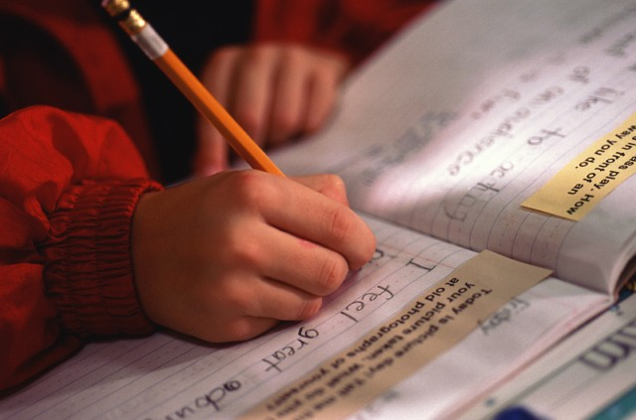

A collaboration between Primary schools and Local Authority
London Borough of Barking and Dagenham

Version 1 (draft) – 2015

Contents:
Introduction | p. 3
Year 5 checklist | p. 5
Working towards expected standard | p. 6
Work samples – working towards | p. 14
Working at expected standard | p. 19
Work samples - expected | p. 29
Working at mastery standard | p. 34
Work samples - mastery | p. 45

Bibliography
National Curriculum Programmes of Study for English
LBBD Writing Continuum
Rising Stars Progression Framework
Primary Strategy – Letters and Sounds
Primary Strategy – Grammar for Writing

Acknowledgements
This series of documents has been written by:
Jonathan Chase (Roding Primary)
Carrie Cox (Marks Gate Junior)
Hadleigh Ford (Thomas Arnold Primary)
Gareth Jukes (Marks Gate Junior)
Praneeta Kasiram (Northbury Primary)
Lauren Pearce (Parsloes Primary)
Rosie Phipps (Dorothy Barley Infants)
Meeta Solanki (Warren Junior)
Ian Tasker (Thomas Arnold Primary)
Amy Walker (Marks Gate Infants)
Andrew Willmer (John Perry Primary)
Nicola Wix (LBBD)

With additional contributions from:
Sophie Charles (George Carey Primary)
Jaime Collins (Furze Infants)
Julia Gooding (Roding Primary)
Norma Marshall (Hunters Hall Primary)
Gill Massar (William Bellamy Primary)
Toni Morphew (Hunters Hall Primary)
Gillian Bratley (LBBD)

Assessment and Accountability – Life after Levels
Barking and Dagenham

Introduction
When the new National Curriculum became statutory in September 2014, it was clear that the Government was not going to introduce a replacement system for the outgoing levels of attainment.

Following the Government’s consultation on primary school assessment and accountability in 2013, it published its response in March 2014. In that response it stated that the reforms in the curriculum and assessment are based on a clear set of principles:
- ongoing, teacher-led assessment is a crucial part of effective teaching;
- schools should have the freedom to decide how to teach their curriculum and how to track the progress that pupils make;
- both summative teacher assessment and external testing are important;
- accountability is key to a successful school system, and therefore must be fair and transparent;
- measures of both progress and attainment are important for understanding school performance;
- a broad range of information should be published to help parents and the wider public know how well schools are performing.
Reforming assessment and accountability for primary schools

Whilst many schools have continued using levels for the 2014-15 academic year, they are aware this practice cannot continue indefinitely as levels do not fit with the new National Curriculum. Rather than each school create its own assessment system, there was a desire from a number of schools for a collective system to be created, to help with moderation amongst groups of schools and mobility between schools.

A group of colleagues from schools and the School Improvement Service in Barking and Dagenham have been working hard to produce a set of materials that schools can use to assess children’s understanding and determine the appropriate next steps. These materials include:
- Exemplification documents for reading, writing and maths – Rubric documents;
- Tracking system for reading, writing and maths for use within Integris.

Formative assessment
Ongoing formative assessment – monitoring pupils’ learning – is still the aspect of assessment that will have the most powerful effect in the classroom, and will move children’s learning on. Identifying what a child can do and what the next steps are is an integral part of teaching practice, and it is not applicable to formally record the tracking of each minute step. A number of schools use the NAHT’s Key Performance Indicators (KPIs) when tracking pupils’ progress through the programme of study for reading, writing and maths. In order to be effective when tracking against the KPIs, or indeed the complete set of year group statements in the National Curriculum, teachers need to be confident at understanding the statements within the relevant year group / phase, and how to support their children in achieving the standards.

Summative assessment
There will still be a need for regular summative assessment – evaluating pupils’ learning – to track a pupil’s attainment against a standard or benchmark. Whereas in the old National Curriculum teachers could assess against the standard measure of levels, there is not a standard measure in the same way with the new National Curriculum. This is where these exemplification documents can support schools by providing a benchmark for the different standards.

Exemplification documents for reading, writing and maths – Rubric documents
Rubric: A document that articulates expectations, by listing criteria and describing levels of quality.
At different points in the year, schools will want to identify whether their pupils are working at, above or below the expected standard for their year group. The programme of study documents the content that needs to be taught in each year group, but there are no samples of work to further exemplify these different stages.
The Rubric documents have been designed to assist with this exemplification. It is envisaged they will be used by schools for moderation purposes both within their school and across groups of schools.

Year group checklist
Each year group checklist provides a summary of the expected standard for each year group. The document can be used by teachers when moderating a child’s work – how well are they demonstrating each standard across a range of work. The NOFAN (Never, Occasionally, Frequently, Always, Naturally) approach has also been used to help teachers decide where a child ‘fits’.

These documents provide exemplification for the following standards within each year group:
- working towards the expected standard;
- at the expected standard;
- mastery of the expected standard.
On each of the documents the programme of study is listed, with what the evidence of attainment might look like, and the exemplification of the standards – what a teacher might do to help their pupils attain this standard. Samples of work are also provided for further exemplification.

It is intended that this document be used as part of the assessment process when deciding the standard the child is working at:
- using a range of work samples and the ‘best-fit’ approach comparing the work samples to the exemplification in this document
- tracking of the objectives within the national curriculum, whether that be through paper-based tracking, Integris or another system.

As further guidance is produced from both the DfE and the Borough, this document will be updated.

v1. September 2015

Name: |  |  |  |  |  |  | Class:
Writing Year 5 |  |  | Emerging (1) |  |  |  | Expected (2) | Exceeding (3)
 |  |  | Below |  | Working Towards |  | Expected | Above Expected |  | Mastery
 |  |  | Never |  | Occasionally |  | Frequently | Always |  | Naturally
Transcription – Spelling, handwriting and presentation
Accurate spelling of common words and taught words
Reasonable attempt at unfamiliar words
Distinguishes and correctly spells homophones
Uses knowledge of spelling patterns to spell unfamiliar words
Can spell words that use prefixes and suffixes
Can navigate a dictionary
Handwriting is consistent, fluent and legible
Composition
Able to identify audience and general purpose of writing
Use notes and research to develop initial ideas when planning for writing
Improves writing by proof-reading and editing
Emulate the style of a studied author
Use suitable writing model to support their writing
Use key features of taught genres
Use detailed description to portray characters, setting and atmosphere
Use paragraphs to organise the content of the writing
Writing links ideas within and across paragraphs
Writing flows and make sense
A range of sentence types and lengths used effectively throughout the writing
Attempts to engage the readers thoughts and feelings
Clear beginning, middle and end
Balanced use of dialogue to develop plot
Uses conjunctions to link sentences and paragraphs
Uses appropriate informal / formal tone
Vocabulary, grammar and punctuation
Experimenting with new vocabulary, with some success
Range of punctuation used with some accuracy
Tenses throughout the writing are usually correct
Experimenting with similes and metaphors
Generally subject-verb agreement is correct
Uses prepositions
Identifies word classes within a sentence
Adjectives are used to expand nouns
Modal verbs are used to indicate degrees of possibility
Adverbs are used to expand verbs
Who, which, where, when, whose, that, with are used to create relative clauses
Consistent use of full stops, capital letters, brackets, exclamation marks and question marks
Commas used in lists, to add extra information and to separate clauses
Apostrophes used for contractions, omissions and determiner
Speech marks generally used correctly to punctuate dialogue
Uses a thesaurus to introduce varied and precise vocabulary
Overall Judgement
Autumn 1 | Autumn 2 | Spring 1 |  | Spring 2 |  | Summer 1 |  |  | Summer 2

National Curriculum description  NAHT Key performance indicators in bold  Objectives more suitable to Year 6 in italics | Evidence of attainment | Exemplification
Writing – transcription
Spelling – Pupils should be taught to:  - use further prefixes and suffixes and understand the guidance for adding them | - Pupil can, with support, spell words with prefixes and suffixes with or without associated changes in spelling.  - Pupil can, with support, sometimes convert nouns or adjectives into verbs.  - Pupil is aware of how the meaning changes when adding prefixes and suffixes.  - Pupil can, with support, use prefixes to generate new verbs. | - Get children to use a wider range of graphic information to spell monosyllabic and polysyllabic words. For example, prefixes ‘tele, bi, anti’; suffixes ‘tion, ent’; building from other words with similar patterns and meanings ‘medicine/medical’; and making comparatives ‘ –er, -est, -ish’.  - Get the children to consider how prefixes / suffixes can change the word class e.g. converting nouns or adjectives into verbs using suffixes [for example, –ate; –ise; –ify] and verb prefixes [for example, dis–, de–, mis–, over– and re–]  - Introduce some common spelling rules. For example, the i before e rule – i comes before e, except when followed by a c or when the sound is ay - [tied replied, receive beige, weigh].  - Children should investigate these rules and find exceptions to them.
- spell some words with ‘silent’ letters [for example, knight, psalm, solemn] | - Spells some common kn, mb and stle words correctly: e.g. knee, thumb, rustle. | - Get children to collect these words and investigate them to see if they can establish a rule and then find exceptions to the rule. The letter B is usually silent when used after the letter M and also before the letter T. Examples after M: Jamb, Lamb, Comb, and Tomb. Examples before T: Subtle, Doubt
- continue to distinguish between homophones and other words which are often confused | - Distinguishes and correctly spells some confusing pairs: e.g. led/lead, farther/father, aloud/allowed, new/knew, herd/heard, steal/steel, past/passed, weather/whether, whose/who’s. | - Get children to find the meanings of the words by using a dictionary. Create a class / wall dictionary/ spelling journal in order to make clear the meaning of each word. Children could illustrate these.  - Get children to collect and investigate words, create posters, silly sentences and illustrations, play matching games, bingo, say the word in a sentence.  - Get children to use a wider range of graphic information to spell monosyllabic and polysyllabic words. For example, a range of homophones ‘rain/reign/rein’.  - NB A homograph is a word that shares the same written form as another word but has a different meaning ‘bat, ring, wind’
- use knowledge of morphology and etymology in spelling and understand that the spelling of some words needs to be learnt specifically, as listed in English Appendix 1  - use dictionaries to check the spelling and meaning of words  - use the first three or four letters of a word to check spelling, meaning or both of these in a dictionary  - use a thesaurus. | - Uses conventional spelling. In addition, is able to spell most of the words from Year 3/4 list and some of the Year 5/6 spelling list.  - With support, pupil is able to draw on known root words to correctly spell inflected words and other words related by meaning; has some successful strategies for learning and recalling spelling of anomalous words.  - With support, pupil can navigate a dictionary to find the initial letter of any word and use the guide words to fine tune their search to the second letter, then read and understand the definition.  - Pupil can, with support, sometimes use a thesaurus to introduce varied and precise vocabulary. | - Model the use of a dictionary in order to find meanings of words. Discuss with the children that we often find words which come from the same families together, for example medicine, medical, medic, unless they have a prefix e.g. biomedical.  - Encourage the use of dictionaries, including etymological dictionaries, to find meanings and origins of words.  - Children should have an understanding of other conventions. For example, eponyms ‘guillotine – Joseph-Ignace Guillotin’; and word origins, such as, ‘ pyjamas [India]’, ‘kiwi [New Zealand]’, ‘spaghetti [Italy]’.
Handwriting and presentation – Pupils should be taught to:  - write legibly, fluently and with increasing speed by:  - choosing which shape of a letter to use when given choices and deciding whether or not to join specific letters  - choosing the writing implement that is best suited for a task. | - Pupil handwriting is, joined, consistently neat, legible and joined and of appropriate size.  - With support, pupil can make choices over letter shapes and joins to ensure fluency and legibility.  - Pupil can select the appropriate writing instrument: e.g. a pen for formal writing, a pencil for note taking. | - Get children to use joined handwriting. This should be consistent throughout their writing except where other special forms are required. For example, printing for posters, or computer generated work.  - They should use a full range of joins which include all ascenders and descenders. Writing should sit on the lines and the heights of letters should be sized with growing consistency.  - Children should have developed a style of handwriting which is recognisable as their own.  - The joined writing should enable children to transcribe at an efficient, fluent pace.
Writing – composition
Pupils should be taught to:  - plan their writing by:  - identifying the audience for and purpose of the writing, selecting the appropriate form and using other similar writing as models for their own | - Pupil can recall the key features of a text e.g. use of dialogue in a story, use of first person for a letter, use of imperative in instructions, but may not consistently apply the key features throughout a text.  - Pupil can usually identify the intended audience and purpose for writing  - Pupil attempts to use a formal tone where needed, but may slip into informal tone during the writing.  - Pupil shows some imagination through language used to create emphasis, humour, atmosphere or suspense, although there may be times when the pupil lapses into cliché.  - Pupil attempts to use complex sentences with varied, not consistent, success  - Pupil uses some sentence variation created, e.g. direct speech, adverbials. | - Get children to understand that they can write for a range of purposes. They should understand that when they write for different reasons, the writing will have different features. For example, if they are writing an explanation of a science experiment they may begin with their hypothesis. They should be able to discuss features of their writing.  - Children should be able to write narrative, poetry, non-chronological reports, newspaper reports, recounts, instructions and explanatory texts.  - With narrative they should understand that stories have a beginning, middle and an end [plot] and that there are different genres of fictional writing. For example, ‘mystery/romance/historical’. Children should understand that stories can open differently depending on the impact the writer wants to make on the reader. For example, by using descriptions, actions or dialogue. They need to understand that characters in stories are interlinked with the plot and that plot can be moved on through dialogue. Children should understand the notion of setting and how settings change as stories progress. They should understand that stories are told by a narrator usually in the third person and are written consistently in the past tense.  - Children should be able to write rhyming and non-rhyming poetry in response to a range of stimuli. For example, different types of poems such as haiku, riddles, narrative.  - In non-fiction writing, children should be able to write non-chronological reports with a general opening statement. For example, “There are many reasons why television is bad for children and many why it is good,” and then a more specific comparison of two aspects of that statement. For example. “On the one hand, television is good because….On the other hand television is not good because…”  - Children should be able to write simple newspaper reports that include headlines, facts, opinions, quotations, photos and captions. These reports should focus on ‘news’ relevant to the children’s experience and/or interest.  - They should be able to write recounts that are chronologically ordered and give more detail about events. For example, “Logi Baird was born in…As a young boy he…”  - Children should be able to write instructions, using numbers, imperative verbs and adverbs telling how, where or when something should happen. For example, “1. Once lunch has finish check that all pupils are back in class. 2. Report any children who are lingering in the corridors to the teacher. 3. Make sure all coats and off the floor and hung correctly on the coat hooks.”  - Children should be able to write explanatory texts. For example, explanation of a science experiment which may include an initial hypothesis.
- noting and developing initial ideas, drawing on reading and research where necessary | - Pupil can, with support, sometimes think aloud and record their ideas, sometimes drawing on independent reading and research.  - Pupil can discuss their planning and, with help, be analytical about their own work | - Teach children the skills of planning and then returning to planning in order to further develop ideas. For example, creating a story map, adding further notes when boxing up and finally writing.  - When working on non-fiction, allow time for children to research in groups, pairs, individually in order to gather more information at different depths. Create a bank of ideas which will then strengthen their writing.
- in writing narratives, considering how authors have developed characters and settings in what pupils have read, listened to or seen performed  - draft and write by:  - selecting appropriate grammar and vocabulary, understanding how such choices can change and enhance meaning | - With support, pupil can draw on what they have learned about how authors develop characters and settings to help them create their own.  - Pupil can express a viewpoint in written form (opinion, attitude, position), which may not always be consistent or maintained.  - Pupil is able to plan writing but may still need scaffolding in order to structure writing. Content may be imbalanced, e.g. led predominantly by dialogue, rushed ending.  - Pupil can, with support, select appropriate grammar and vocabulary and is beginning to understand how such choices can change and enhance meaning. | - Spend time exploring the text during shared /guided reading sessions. Ensure that the language features of a text are considered and analysed.  - Help the children to decide what impact the author was trying to make and what impact was actually made on them as readers.  - On the working wall/ workbooks collect words and phrases and styles of writing that they might want to emulate or develop.  - Get children to include more information by using effective grammar and ambitious vocabulary which enhances the meaning and/or the mood of their writing. For example:  - by using proper nouns such as the names of places or characters;  - using a range of pronouns, such as, ‘they/their’ to avoid repetition;  - by using connecting words and phrases to add cohesion, such as ‘meanwhile/provided that’.
- in narratives, describing settings, characters and atmosphere and integrating dialogue to convey character and advance the action | - Pupil can use setting and characterisation to engage readers’ interest. There is an attempt to interest the reader  - Pupil can, with support, describe settings, characters and atmosphere and is beginning to experiment with integrating dialogue to convey character and advance the action.  - Pupil can describe settings and characters using adjectives, choosing and combining words (e.g. blistering heat), verbs, (e.g. the stranger strolled across the road), images and other features for particular effect, e.g. metaphor (the clap of thunder), simile (as big as a bus), alliteration (dastardly devil). | - Get children to include more information by using effective, ambitious vocabulary which enhances the meaning and/or the mood of their writing. For example:  - using adverbs [how] to qualify verbs, such as ‘stealthily’;  - using adverbial words and phrases, such as ‘out of the corner of his eye’ to qualify when or where something happened;  - using powerful verb choices, such as ‘grappling’;  - by adding more sophisticated adjectives, such as ‘functional/suspicious’.  - They should be encouraged to include these to add detail when generating simple compound and complex sentences for writing. For example, “Out of the corner of his eye, Bob saw the boys from the Princetown Gang. They gave him a suspicious look. Grappling with fear, he gingerly made his way down the deserted street.”  - Children should understand and use figurative language, for example, simile, metaphor, personification for effect. For example, “As cool as a cucumber, [simile] the stranger walked down the middle of the street.” “He has a heart of stone.” [metaphor]. “The wind screamed [personification] around the rocks.”
- précising longer passages | - Pupil can, with support, précis longer passages. | - Through deep discussion at shared/guided reading time get children to discuss the main themes and ideas conveyed in the text.  - Encourage children to summarise in 10 words /4 sentences what the chapter, story, text is about. It is possible to focus around a particular theme, character or idea.  - Get children to create a feelings map/ story map which helps them to pick out the main elements of the story.
- using a wide range of devices to build cohesion within and across paragraphs  - using further organisational and presentational devices to structure text and to guide the reader [for example, headings, bullet points, underlining] | - Pupil can, with support, organise writing into a logical sequence of paragraphs: e.g. by using pronouns or adverbials within paragraphs to link to subjects introduced in the opening sentence.  - Pupil can write in paragraphs, beyond the paragraphs used for organisational purposes.  - Pupil can, with support, sometimes use further organisational and presentational devices, to structure text and to guide the reader: e.g. use headings and subheadings, organise ideas so related points are grouped, signal openings and closings.  - Pupil is able to use basic conjunctions to clarify the relation between time, place and setting, although some of the more complex conjunctions are used awkwardly or inaccurately.  - Pupil demonstrates some flow and cohesion in their work, although this may not be sustained. | - Get children to generate and write their ideas linking them using cohesive devices. For example, connecting words and phrases such as ‘after the rains had past’.  - Children should develop their ideas by including additional information with the audience in mind. For example, by using dialogue to move a narrative forward, or by adding more detail in non-fiction writing.  - When working on non-fiction ensure that children are clear about the organisational features and the ‘job’ that they do.  - This should be done over more sustained pieces of work.  - Children should organise their work in paragraphs, in places some may be more developed than others.
- evaluate and edit by:  - assessing the effectiveness of their own and others’ writing | - Pupil can, with support, sometimes work alone and with a partner to evaluate writing against agreed success criteria, identifying aspects for alteration linked to previous teaching.  - Pupil can discuss their writing and, with help, be analytical about their own work  - Pupil is able to make suggestions about improvements in their own work and is beginning to see their writing from the reader’s point of view.  - Pupil can, with support, perform their own compositions, beginning to use appropriate intonation, volume, and movement so that meaning is clear. | - Get children to re-read their work, sometimes with support. They should do this after each paragraph of writing especially in longer pieces.  - Encourage and build the skill of partner work in order to develop evaluation skills against agreed criteria.  - Make sure that children respond to the writing in terms of how it makes them feel and what they have enjoyed reading/hearing.
- proposing changes to vocabulary, grammar and punctuation to enhance effects and clarify meaning  - ensuring the consistent and correct use of tense throughout a piece of writing  - ensuring correct subject and verb agreement when using singular and plural, distinguishing between the language of speech and writing and choosing the appropriate register  - proof-read for spelling and punctuation errors | - Pupil can discuss their writing and, with help, be analytical about their own work  - Pupil can, with support, sometimes propose appropriate changes to vocabulary, grammar and punctuation to clarify meaning in their own and others’ writing.  - Pupil can, with support, sometimes write using tense consistently and correctly throughout.  - Pupil can, with support, understand that some colloquial spoken subject/verb pairings do not agree and use correct forms in writing: e.g. we were (not we was).  - Pupil can, with support, identify examples of informal speech patterns and structures in their own writing and amend to reflect Standard English usage where appropriate.  - Pupil can, with support, can spot some of their own and others’ spelling and punctuation errors but does not always notice errors in the most recently taught spelling patterns and punctuation items.  - Pupil requires some support to find their own mistakes for editing purposes, particularly the more obvious mistakes. | - Get children to re-read their work, sometimes with support. They should do this after each paragraph of writing especially in longer pieces.  - Get children to generate simple, compound and complex sentences which show an understanding of grammatical constructions. For example:  - the consistent use of tense, such as past tense for narrative/present tense for instructions,  - noun/verb agreements, such as ‘he was/they were’,  - verb/tense agreements such as ‘we are looking /we will look/ we looked’  - and irregular verb/tense agreements such as ‘froze/freeze/frozen, dream/dreamt’.  - In shared editing sessions demonstrate by using children’s writing, where cohesion could be improved. For example, by explaining that they could use an adverbial phrase to link two ideas, like ‘much later on’.  - Get children to generate ideas as to how their writing could be improved. For example, by making suggestions like, “I could add a causal connective like therefore, to link the actions of the characters.”  - Discuss with the children that how they speak and write is different. Explain that it is their job to be clear for the reader and this is done through a common written language. That’s why it is fine to talk how you want to, but writing must be different.
Writing – vocabulary, grammar and punctuation
Pupils should be taught to:  - develop their understanding of the concepts set out in English Appendix 2 by:  - using the perfect form of verbs to mark relationships of time and cause | - Pupil is beginning to choose when to use the present perfect tense in contrast to the past where appropriate.  - Pupil can generally use tense correctly, including some use of modals (can, will) , although there may be inconsistency in more complicated pieces of writing e.g. flashbacks  - Pupil can use subject-verb agreement correctly | - Get the children to experiment with sentences in the context of their writing. (Particularly useful when doing character descriptions, biographies)  - NB We use the present perfect to say that an action happened at an unspecified time before now. The exact time is not important. You CANNOT use the present perfect with specific time expressions such as: yesterday, one year ago, last week, when I was a child, when I lived in Japan, at that moment, that day, one day, etc.  - We CAN use the present perfect with unspecific expressions such as: ever, never, once, many times, several times, before, so far, already, yet, etc.  - Experience-You can use the present perfect to describe your experience. It is like saying, "I have the experience of..." You can also use this tense to say that you have never had a certain experience.” I have been to France. I have never been to France.” This sentence means that you have had the EXPERIENCE of being in France; maybe you have been there once, or several times.  - Change Over Time-We often use the present perfect to talk about change that has happened over a period of time. Examples: “You have grown since the last time I saw you; The government has become more interested in arts education; My English has really improved since I moved to Australia.”  - Accomplishments-We often use the present perfect to list the accomplishments of individuals and humanity. You cannot mention a specific time. “Man has walked on the Moon; Our son has learned how to read; Doctors have cured many deadly diseases.”  - An Uncompleted Action You Are Expecting -We often use the present perfect to say that an action which we expected has not happened. Using the present perfect suggests that we are still waiting for the action to happen. Examples: “James has not finished his homework yet. The rain hasn't stopped. Susan hasn't mastered Japanese, but she can communicate.”  - Multiple Actions at Different Times - We also use the present perfect to talk about several different actions which have occurred in the past at different times. Present perfect suggests the process is not complete and more actions are possible. Examples: “The army has attacked that city five times. I have had four quizzes and five tests so far this year. She has talked to several specialists about her problem, but nobody knows why she is sick.”
- recognising vocabulary and structures that are appropriate for formal speech and writing, including subjunctive forms  - using passive verbs to affect the presentation of information in a sentence | - Year 6 content
- using expanded noun phrases to convey complicated information concisely | - Pupil is able to use expanded noun phrases  - Pupil is able to use expanded noun phrases with growing precision in order to convey detailed information concisely.  - Pupil can add some details/description of events or ideas expanded through vocabulary (e.g. fronted adverbials, adjectives), or explanation. Some vocabulary selected for effect, appropriateness to task. | - Recap previous grammar knowledge acquired and touch on areas of uncertainty, particularly nouns, adjectives and commas in a list.  - Explain that nouns are the subject or object of a verb. In the sentence, “The girl sat on the wall”, “sat” is the verb, “girl” is the subject and “wall” is the object. Phrases are groups of words that work together; in a phrase, there will be one word that all the other words modify. In a noun phrase, the other words will be modifying a noun. In the sentence above, “girl” is a noun; “the girl” is a simple noun phrase. This can then be expanded with an adjective: “the tall girl” is an expanded noun phrase, albeit a very straightforward one.  - Expanded noun phrases allow us to communicate precise information in a quick, concise way. The adding of adjectives before nouns is a basic skill in the building of description, and is the simplest way to expand a noun phrase, but it requires practice to do well. Redundant adjectives should be avoided: “The soggy, wet flannel”, where soggy and wet say the same thing; “The huge giant”, where the adjective is adding no value to the already descriptive noun. Adjectives should be chosen to convey precise meaning, and where they are not needed, simplicity may be best: “The big, black, powerful Rottweiler” may not tell the reader more than “The Rottweiler”; “The small, cuddly Rottweiler” conveys useful additional information.
- using modal verbs or adverbs to indicate degrees of possibility | - With support, pupil is beginning to use modal verbs or adverbs to indicate degrees of possibility. | - Get the children to examine texts where modal verbs are used. They can express meanings such as certainty, possibility, ability, or obligation. In grammar lessons and cross curricular writing, ask the children to consider outcomes, e.g. the water might travel up the stem of the flower.  - Ask the children to apply this in their writing of non-fiction. For example, “Sharks in caves, waiting for prey that may eventually pass”; “Dear Mr Brown, I was hoping that we might discuss this matter on the phone.”  - Children may only be able to understand the most obvious forms, but not always consciously use these in their writing.  - NB Modal verbs are used to change the meaning of other verbs. The main modal verbs are will, would, can, could, may, might, shall, should, must and ought. A modal verb only has finite forms and has no suffixes (e.g. I sing – he sings, but not I must – he musts).
- using relative clauses beginning with who, which, where, when, whose, that or with an implied (i.e. omitted) relative pronoun | - With support, pupil is beginning to use relative clauses beginning with who, which, where, when, whose, that or with an implied (i.e. omitted) relative pronoun. | - Allow children to build and play around with sentences, adding in relative clauses, to further explain the sentence.  - Get children to use these to describe character.  - NB A relative clause is a special type of subordinate clause that modifies a noun. It often does this by using a relative pronoun such as who or that to refer back to that noun, though the relative pronoun that is often omitted. A relative clause may also be attached to a clause. In that case, the pronoun refers back to the whole clause, rather than referring back to a noun.  - Examples: “That’s the boy who lives near school.” [who refers back to boy] “The prize that I won was a book.” [that refers back to prize] “The prize I won was a book.” [the pronoun that is omitted] “Tom broke the game, which annoyed Ali. [which refers back to the whole clause]”
  - learning the grammar for years 5 and 6 in English Appendix 2
- indicate grammatical and other features by:  - using commas to clarify meaning or avoid ambiguity in writing | - Pupil is not yet consistent in deploying commas to clarify meaning or avoid ambiguity: e.g. may be unable to distinguish the difference in meaning between “Most of the time, travellers worry about their luggage.” And “Most of the time travellers worry about their luggage.”  - More than half the sentences are correctly demarcated, even when sentence structure varies.  - Full stops, capital letters, exclamation marks and question marks are used mostly accurately.  - Pupil can include dialogue where relevant and is able to punctuate it and is developing skill and confidence at punctuating within it.  - Use of the apostrophe for possession. | - Get the children to extend a sentence by placing a subordinate clause before or after the main clause. Ensure children place a clause between the main and subordinate clause in order to clarify meaning. For example, “Though he was very rich, he was still very unhappy.” OR “He was still very unhappy, though he was very rich.”  - Get the children to cut up a main clause and place in a subordinate clause. For example, “The policeman, who was clearly angry, chased the robber.” Teach children that they can use an embedded clause to add information to a sentence or make it clearer.  - Explain to the children that they will need to separate a main clause by adding information with a subordinate clause, which can be moved about but it may change the meaning of the sentence.  - Let the children decide what they wish to convey, moving the subordinate clause around within the sentence. Which sentence is closest to what they want to say? Then punctate with commas.
- using brackets, dashes or commas to indicate parenthesis | - With support, pupil can identify which word, phrase or clause of a sentence they are writing or proof-reading needs parenthesis.  - Pupil is not always sure whether brackets, dashes or commas are the most appropriate in each case and tends to make the same choice every time | - Teach the children the function of the three types of parenthesis, by sorting sentences, creating a sentence and adding in extra information, creating human sentences.  - NB A parenthesis is additional information added into a sentence as an explanation or an afterthought. For example (parenthesis shaded): “John, a 7-year-old cat from Doncaster, hid in the engine area of his owner's car for a 60-mile trip to the seaside.” “Peter, I've heard it said, used to be a teacher before he took up body building.”  - When a parenthesis is completely removed, the sentence is still grammatically correct. A parenthesis can be separated from the rest of the sentence by commas, dashes, or brackets (all called parentheses).
- using hyphens to avoid ambiguity using semi-colons, colons or dashes to mark boundaries between independent clauses  - using a colon to introduce a list  - punctuating bullet points consistently | - Year 6 content | - Explain where colons are used to introduce a list (frequently in non fiction writing and for emphasis in fiction). The job of the colon is simple: to introduce.  1. Use a colon to introduce a list:  There are three countries in North America: Mexico, the USA and Canada.  We can see many things in the sky at night: the moon, stars, planets, comets, planes and even satellites.  2. You can use a colon to introduce a single item, especially when you want to emphasize that item:  We were all waiting for the hero of the evening: John.  There is one thing that he will not accept: stupidity.  3. Use a colon to introduce direct speech or a quotation:  He stood up and said loudly: "Ladies and Gentlemen, please be seated."  John whispered in my ear: "Have you seen Andrea?"  As Confucius once wrote: "When words lose their meaning, people lose their freedom."  4. Use a colon to introduce an explanation:  We had to cancel the party: too many people were sick.  There is no need to rush: the meeting will be starting one hour late.  5. Use a colon to introduce examples, as shown above. For example, item 1 above reads "Use a colon to introduce a list" and ends with a colon followed by two example sentences..
- use and understand the grammatical terminology in English Appendix 2 accurately and appropriately in discussing their writing and reading. | - Pupil shows a growing understanding of grammar terminology appropriate to age. (noun verb adjective adverb, clauses, phrases)  - Pupil knows what function the grammar has  - Pupil is beginning to make choices about the grammar they use.  - Pupil is beginning to discuss their grammatical choices in writing and discuss an author’s grammatical choices in reading | - Teach children the correct metalanguage when in shared reading and shared writing sessions and teach the function of words, demonstrate how these are used.

Year 5 Working towards, example 1 | Exemplification
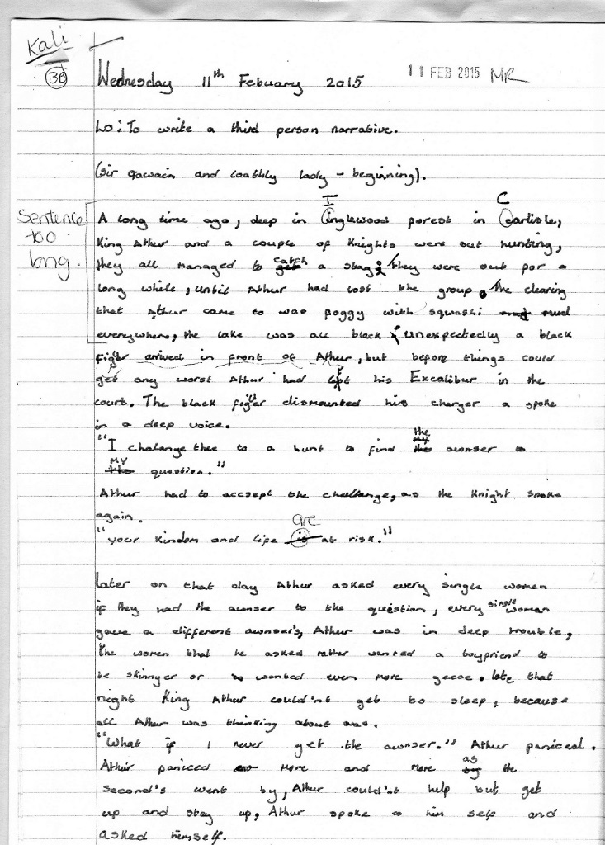 | Transcription:  - Generally high frequency words spelt correctly  - Not always applying spelling patterns to suffixes
Composition:
- Some evidence of integrating dialogue to convey character and advance the action
- Description of setting and character
- Use of paragraphs
- Proof reading for corrections in spelling and punctuation

Vocabulary, spelling & grammar:
- Experimenting with new vocabulary
- Beginning to use homophones correctly
- Experimenting with use of apostrophes

Context:
- Based on text
- Scaffolded and first paragraph modelled
- Independent writing
- Final piece at end of the year

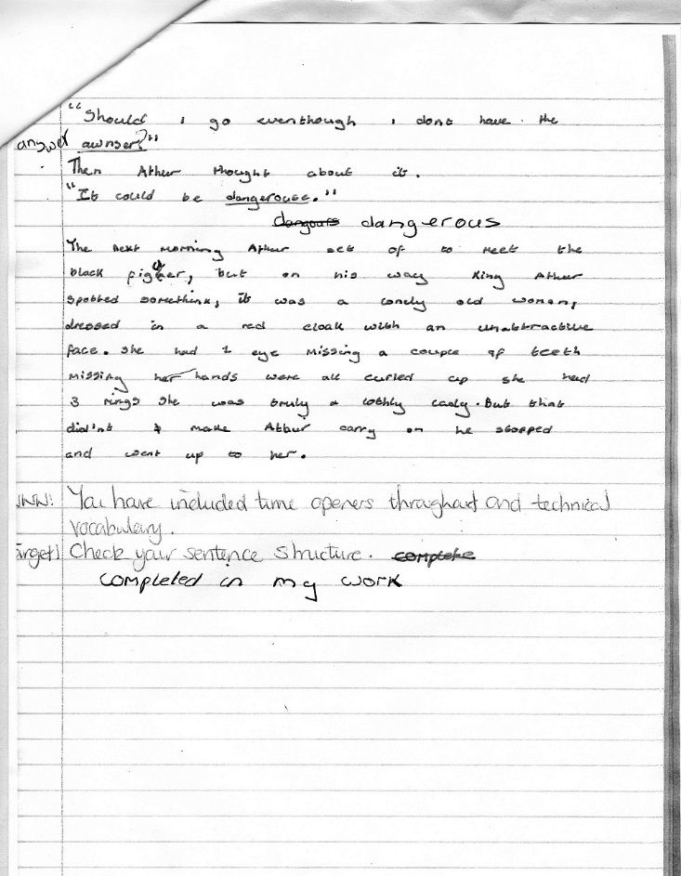

Year 5 Working towards, example 2 | Exemplification
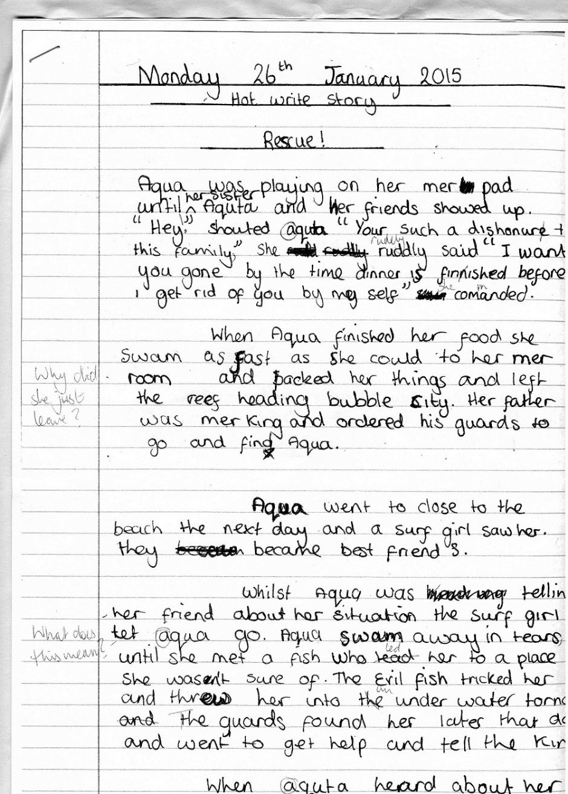 | Transcription:  - Not yet able to distinguish between homophones  - High frequency words spelt correctly
Composition:
- Use of paragraphs to organise writing
- Beginning to integrate dialogue in order to advance the action
- Beginning to link paragraphs

Vocabulary, spelling & grammar:
- Beginning to experiment with new vocabulary
- Inconsistent use of capital letters and full stops
- Clear beginning, middle and end being developed
- Limited range of punctuation used — ”” . A

Context:
- Previous experience of story writing and modelling
- Whole piece of writing independent

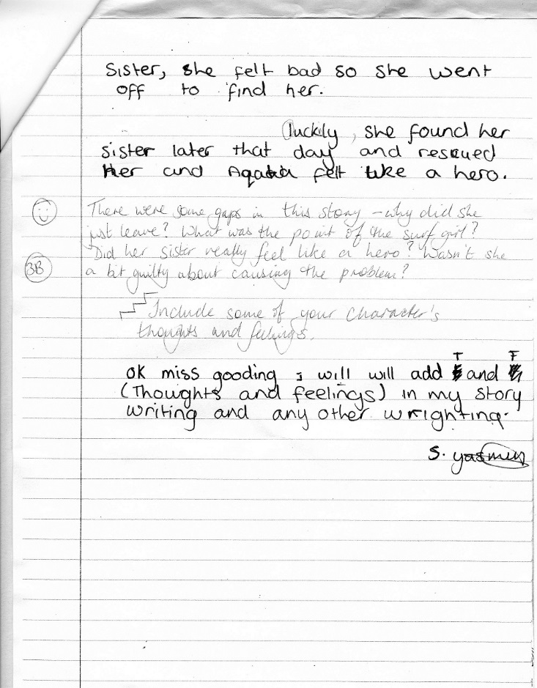

Year 5 Working towards, example 3 | Exemplification
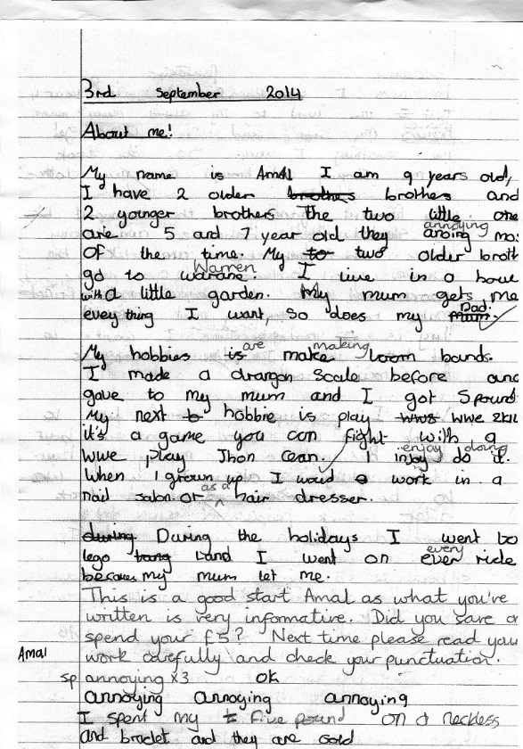 | Transcription:  - Inconsistent joining in handwriting  - Not applying knowledge of spelling patterns when attempting unfamiliar words
Composition:
- Use of paragraphs to organise writing
- Some evidence of proof reading to correct spelling and punctuation
- Limited range of sentence type and length
- Lack of detail and description
- Not using conjunctions to join sentences and paragraphs

Vocabulary, spelling & grammar:
- Limited range of punctuation used .- A
- Inconsistent use of capital letters.

Context:
- Title given
- Brainstorming
- Independent planning and writing

National Curriculum description  NAHT Key performance indicators in bold  Objectives more suitable to Year 6 in italics | Evidence of attainment | Exemplification
Writing – transcription
Spelling – Pupils should be taught to:  - use further prefixes and suffixes and understand the guidance for adding them | - Pupil can usually spell words with prefixes and suffixes with or without associated changes in spelling: e.g. applicable, adorable, reliable, changeable, noticeable  - Pupil can usually convert nouns or adjectives into verbs: e.g. hyphen into hyphenate; terrible into terrify and is able to grasp how the meaning and function changes  - Pupil can use prefixes to generate new verbs: e.g. disapprove; defuse, misunderstand, overestimate, recombine.  - Spells words containing unstressed vowels, e.g. market, mountain, and words with common prefixes, e.g. disappear, uncomfortable, impossible.  - Attempts to spell an increasing range of unfamiliar polysyllabic words using knowledge of conventions, rules and increased range of strategies, e.g. hopeful, careful, shameful. | - Get children to use a wider range of graphic information to spell monosyllabic and polysyllabic words. For example, prefixes ‘tele, bi, anti’; suffixes ‘tion, ent’; building from other words with similar patterns and meanings ‘medicine/medical’; and making comparatives‘ –er, -est, -ish’.  - Get the children to consider how prefixes / suffixes can change the word class, for example converting nouns or adjectives into verbs using suffixes [for example, –ate; –ise; –ify] and verb prefixes [for example, dis–, de–, mis–, over– and re–]
- spell some words with ‘silent’ letters [for example, knight, psalm, solemn] | - Spells most common kn, mb, stle, mn, silent b words correctly: e.g. as at left, and solemn, debt. | - Get children to collect these words and investigate them to see if they can establish a rule and then find exceptions to the rule. The letter B is usually silent when used after the letter M and also before the letter T. Examples after M: Jamb, Lamb, Comb, Tomb. Examples before T: Subtle, Doubt
- continue to distinguish between homophones and other words which are often confused | - Distinguishes and correctly spells most confusing pairs: e.g. guessed/guest, serial/cereal, bridal/bridle, altar/alter, desert/dessert, draft/draught, stationary/stationery, principal/principle.  - Developing understanding of homographs and what their meanings are. | - Get children to collect and investigate words, create posters, silly sentences and illustrations, play matching games, bingo, say the word in a sentence  - Get children to spell less common homophones, for example ‘rain/reign/rein’  - A homograph is a word that shares the same written form as another word but has a different meaning; ‘ring, bat, wind’.
- use knowledge of morphology and etymology in spelling and understand that the spelling of some words needs to be learnt specifically, as listed in English Appendix 1 | - Uses conventional spelling. In addition, is able to spell nearly all the words from Year 3/4 list and half of the Year 5/6 spelling list.  - Pupil is usually able to draw on a range of known root words to correctly spell inflected words and other words related by meaning; has some successful strategies for learning and recalling spelling of anomalous words: e.g. using known spelling of ordinary to help spell extraordinary, ordinarily. | - Encourage the use of etymological dictionaries, discuss the meanings and origins of words in spelling lessons.  - Children should have an understanding of other conventions involved in spelling. For example, root words and derivations ‘inter, interject, interrupt, interfere, interval’; eponyms ‘guillotine – Joseph-Ignace Guillotin’; and word origins, such as, ‘ pyjamas [India]’, ‘kiwi [New Zealand]’, ‘spaghetti [Italy]’.  - NB Children should have an understanding of the meanings of the root words, for example, ‘inter means between’.
- use dictionaries to check the spelling and meaning of words  - use the first three or four letters of a word to check spelling, meaning or both of these in a dictionary | - Pupil can navigate a dictionary to find the initial letter of any word and use the guide words to fine tune their search to the third or fourth letter, then independently read and usually understand the definition. | - Model the use of the dictionary in different classroom situations.  - Allow children to use dictionaries in their writing.  - Play skill games/ do dictionary activities.  - Get the children to make their own topic dictionaries/glossaries for the class/ table.  - The use of dictionaries is appropriate & mainly independent.
Handwriting and presentation – Pupils should be taught to:  - write legibly, fluently and with increasing speed by:  - choosing which shape of a letter to use when given choices and deciding whether or not to join specific letters  - choosing the writing implement that is best suited for a task. | - Pupil can usually make choices over letter shapes and joins to ensure fluency, legibility and good presentation.  - Pupil can usually select the appropriate writing instrument: e.g. a pencil for making notes, a pen for formal writing.  - Own style of writing is evident  - Writing is consistent in size and consistent in spacing  - Writing should fit the purpose e.g. Print for posters | - Get the children to be aware of their audience in terms of their presentation, for example when writing for a poster, print should be clear and bold, when writing for a younger audience the writing should be well spaced, when writing for an older audience the writing should be joined and legible.  - Get children to join handwriting. This should be consistent throughout their writing except where other special forms are required. For example, printing for captions, or computer generated work.  - The joined writing should enable children to transcribe at an efficient, fluent pace developing stamina.
Writing – composition
Pupils should be taught to:  - plan their writing by:  - identifying the audience for and purpose of the writing,  . | - Pupil can usually identify the intended audience and purpose for writing  - Pupil’s writing is clear in purpose and incorporates relevant content to inform/engage the reader.  - Pupil can choose a suitable writing model to support their own writing: e.g. an information leaflet for fellow pupils offering guidance and advice on a new sport.  - Pupil shows some use of stylistic features to support purpose (formal/informal vocabulary, appropriate use of similes/metaphors, word choice for effect or emphasis...). Elaboration of detail/events may be supported through vocabulary (technical, precise/vivid language) or through explanation. | - Get children to understand that they can write for a range of purposes. They should understand that when they write for different reasons, the writing will have different features. For example, if they are writing a letter their address would go at the top. They should be able to discuss features of their writing.  - Children should develop their ideas by including additional information with the reader in mind and by maintaining pace throughout in longer pieces of work. For example, in narrative by using dialogue to move the story forward or to give more information about the characters, or in non-narrative, by writing a thought-provoking ending to an informational text.  - With narrative they should understand that stories are structured so that there is an opening, a conflict and a resolution but the plot need not be linear. For example, there could be counter-plots, flashbacks etc. They should understand that characters [motive] and plot are interlinked and that dialogue can move the plot forward. They should understand that stories are told by a narrator usually in the third person and are written consistently in the past tense.  - Children should be able to write rhyming and non-rhyming poetry in response to a range of stimuli using a range of poetic forms. For example, haiku, free verse etc.  - In non-fiction writing, children should be able to write non-chronological reports with a general opening statement. For example, “Whales are the largest ocean-dwelling mammals.” and a more specific comparison of two aspects of that statement. For example. “Unlike the blue whale, killer whales or orca…”  - Children should be able to write simple newspaper reports that include headlines, facts, opinions, quotations, photos and captions. These reports should focus on ‘news’ relevant to the children’s experience and/or interest.  - Children should be able to write explanatory texts. For example, explanations of a science experiment which could explain a hypothesis. Children should be able to produce persuasive writing in a range of forms, including letters, which present arguments for and against a particular issue. They should understand the notion of a balanced view/argument.
- selecting the appropriate form and using other similar writing as models for their own | - Pupil can recall and use of key features of taught genres.  - Pupil writing is beginning to show a secure understanding of the features of a range of text types (choice of tense, verb form, layout, formality...). Ideas may be adapted, e.g. inclusion of contextual information on a fictitious character or the use of quotes within a report.  - Pupil uses different types of sentence structures, e.g. adverbial phrases, short sentences; pronouns establishing links with previous sentences.  - Pupil can use dialogue, when appropriate, to move the story forward.  - Pupil can use reported speech to develop viewpoint  - Pupil is beginning to develop the varying pace to sustain interest, e.g. a narrative would have a balance of action and description, dialogue and characterisation etc. across the whole text.  - Pupil is starting to create good paragraphs across the genre where topic sentences are developed and extended to embellish key idea of the paragraph  - A range of sentence types and lengths used effectively in throughout the writing | - Ensure that children to recall the features of all text types prior to reading them, at this point it would be likely that they would have covered most of the text types. Allow children to analyse the text types; noting both organisational and language features.  - Ensure that their prior knowledge is then built upon, for example, by adding a greater deal of technical language, or generalisers or an even more formal tone, or better grasp of the audience reading the writing.  - Use shared reading and shared writing times to explore texts and their organisational and language features and what they bring to the reader, in terms of how they make us feel or inform us. Use shared writing sessions to model how these devices are used.  - Allow children to plan their work using a variety of methods, e.g. Talk for Writing; text mapping, talking the text, boxing up, story mountains, five finger plans etc. Ensure that enough time is allowed to plan, and children are helped to get to grips with the trickiest parts of the planning process, for example the middle sections and resolution  - Allow children opportunities to write across the curriculum. For example a letter of complaint / within a text / letter writing to grandma, so that the skills that they are developing are practised in other purposeful ways  - They should be encouraged add detail to their writing by generating a range of sentences. For example simple, compound and complex sentences  - Get children to generate a complex sentence with one, or two subordinate clauses. For example, “There was a large house, which when night fell, became the scariest place in the world.” Encourage them to check that each clause has a noun and a verb and that the main clause makes sense by itself.
- noting and developing initial ideas, drawing on reading and research where necessary | - Pupil can usually think aloud and record their ideas, sometimes drawing on independent reading and research: e.g. use a spidergram planning model to organise and develop related ideas drawn from reading and research.  - Pupil can discuss their planning and be analytical about their own work | - Allow children to plan their work using a variety of methods, e.g. Talk for Writing; text mapping, talking the text, boxing up, story mountains, five finger plans etc. Ensure that enough time is allowed to plan, and children are helped to get to grips with the trickiest parts of the planning process, e.g. the middle sections and resolution, or a convincing introduction in non-fiction.  - In shared writing, model how to plan being clear about the thought process that you go through when planning, drawing on any organisational features/ information from non fiction that might need to be included or repetition/refrains/ themes in a poem or a story.  - Allow children to plan in pairs, groups, sharing their ideas and building a secure structure to write from, even if they write individually.
- in writing narratives, considering how authors have developed characters and settings in what pupils have read, listened to or seen performed | - Pupil can usually draw on what they have learned about how authors develop characters and settings to help them create their own: e.g. planning two or three main characters who are clearly distinguishable from each other and placing them in a setting modelled on a favourite story or pupil's own locality.  - Pupil understands how a narrator’s or character’s viewpoint can be established.  - Pupil can establish a viewpoint but this may not be maintained throughout the writing e.g. by a direct appeal to the reader in persuasive writing or an explicit comment on a character by a narrator or another character. | - In shared reading discuss with children the effect that the author has on the reader and the skills that she/he has used to do this.  - In shared writing, model how to include some of the elements that the author has used, for example how a character enters a room, how a character reacts to a problem, how the character moves or is described.
- in narratives, describing settings, characters and atmosphere and integrating dialogue to convey character and advance the action | - Pupil can usually describe settings, characters and atmosphere and integrate dialogue to convey character and advance the action, evoke atmosphere through detailed description, portray characters through meaningful interaction and dialogue that moves the story on: e.g. 'Watch out, you've left the door open!' 'Too late - the dog's made a bolt for it!' | - In the shared reading consider how the story moves from one place/time to another. Examine how the author does this and try to emulate some of the ways of moving plot forward.  - Children should understand the notion of setting and how settings change as stories progress and can convey a sense of what is to come.  - Children should understand that stories can open differently depending on the impact the writer wants to make in the reader. For example, by using descriptions, actions or dialogue.  - Spend time looking at how a plot is moved on in different ways. For example, with dialogue “Night is coming , we must find somewhere to shelter”, or with narration “Soon the night clouds darkened the day”.  - They should understand that stories are told by a narrator usually in the third person and are written consistently in the past tense.
- précising longer passages | - Pupil can usually précis longer passages: e.g. identify key points from the passage and reformulate them coherently in their own words. | - Through deep discussion at shared reading time, guided reading time, get children to discuss the main themes and ideas conveyed in the text.  - Encourage children to summarise in 10 sentences what the chapter, story, text is about. It is possible to focus around a particular theme, character or idea.  - Get children to create a feelings map, which helps them to pick out the main elements of the story.
- using a wide range of devices to build cohesion within and across paragraphs  - using further organisational and presentational devices to structure text and to guide the reader [for example, headings, bullet points, underlining] | - Links may be established between paragraphs, although some transitions may be awkward or abrupt.  - Pupil can use devices to build cohesion, including adverbials of time, place and number: e.g. linking ideas within and across paragraphs using later, nearby, secondly.  - Pupil can put related events or ideas organised into paragraphs generally maintained through use of ongoing references e.g. pronouns, adverbials, connectives (Eventually we…)  - Pupil can usually use further organisational and presentational devices to structure text and to guide the reader: e.g. pose questions as heading or sub-headings, use bullet points to organise material, integrate diagrams, charts or graphs.  - Pupil can usually produce internally coherent paragraphs in a logical sequence: e.g. using topic sentences to pose rhetorical questions which are answered within the paragraph, main idea supported or elaborated by subsequent sentences. | - Re-read their own writing to check for cohesion and identify and make some improvements:  Get children to re-read their work. They should do this after each chunk of writing especially in longer pieces. Demonstrate this by using children’s writing where cohesion could be improved. For example, by explaining that they could use an adverbial phrase at the beginning of the sentence like ‘in a far away place’, to show when the story was happening.  - Explain to the children that useful phrases tell the reader when, where or how something is happening in the sentence. These are called adverbial phrases. For example, ‘Many years ago’ [when] ‘in a deep dark wood’ [where] ‘crept stealthily’ [how].’ Add the phrase to the complex sentence already written. “In a deep, dark wood, there was a house, which when night fell, became the scariest place in the world.”  - NB children should be familiar with the terminology: complex sentence, clause, subordinate clause and adverbial phrase.
- evaluate and edit by:  - assessing the effectiveness of their own and others’ writing | - Pupil can usually work alone and with a partner to evaluate writing against agreed success criteria  - Pupil can usually work alone and with a partner to identify strengths and areas for improvement linked to recent teaching and feeding back appropriately to the writer.  - Pupil can perform their own compositions using appropriate intonation, volume, and movement so that meaning is clear, monitoring and maintaining audience attention, speaking loudly enough to be heard. | - Get children to re-read their work. They should do this after each paragraph especially in longer pieces.  - Encourage and build the skill of partner work in order to develop evaluation skills against an agreed criteria.  - Make sure that children respond to the writing in terms of how it makes them feel and what they have enjoyed reading/hearing.  - Get children to generate idea as to how their writing could be improved. For example, by making suggestions like “I think if I am writing to the mayor to complain, I need to use more formal language to get my points across.”  - Demonstrate this by using children’s writing with a specific audience and purpose in mind. For example, writing formal/informal letters.  - Discuss with the children how they might change a particular piece of writing to improve the impact it has on the reader. Explain that sometimes words and phrases can be added or deleted.
- proposing changes to vocabulary, grammar and punctuation to enhance effects and clarify meaning  - proof-read for spelling and punctuation errors | - Pupil can usually propose appropriate changes to vocabulary, grammar and punctuation to clarify meaning in their own and others’ writing.  - Pupil can usually spot most of their own and others’ spelling and punctuation errors quickly and knows how to correct them, including errors in the most recently taught spelling patterns and punctuation items. | - Get children to read their work through in small sections, making specific suggestions to a writing partner or incorporating such changes in their own writing, such as: “I've written: 'I took a picture of my friend, who won the 200m sprint with his grandmother.' I need to put a second comma in there after 'sprint' to help the reader make sense of what I wrote. It makes the reader think the grandmother sprinted too if I leave it without a comma.”  - Through shared reading and shared writing and grammar lessons, encourage the children to consider the meaning conveyed when commas are in the wrong place. Do they think that the meaning is clear enough?  - Allow children to read their own work allowed, looking for own errors. Use of word collections, dictionaries, spelling rules, will help to strengthen spelling knowledge.  - Examine misspelt sentences in a spelling lesson; gather ideas about how the writer could help themselves to write with increasing accuracy, using a number of spelling skills e.g. syllables.  - In shared editing/grammar / guided writing sessions, read the children’s work without the correct punctuation, ask the children what meaning is conveyed. Work on adding the correct punctuation in a group. What meaning is now conveyed? Is this clearer for the reader.  - Work with children on ‘human sentences’ or rearranging clauses, words in a sentence, in order to strengthen understanding of sentence structure and punctuation
Writing – vocabulary, grammar and punctuation
Pupils should be taught to:  - develop their understanding of the concepts set out in English Appendix 2 by:  - recognising vocabulary and structures that are appropriate for formal speech and writing, including subjunctive forms  - using passive verbs to affect the presentation of information in a sentence.  - using the perfect form of verbs to mark relationships of time and cause | - Pupil can usually use the present perfect form of verbs to mark relationships of time and cause: e.g. She has gone on holiday (and is not yet back, or we would write she went on holiday); The coach has left without you (because you have just arrived late). | - Get the children to experiment with sentences in the context of their writing. (Particularly useful when doing character descriptions, biographies)  - NB We use the present perfect to say that an action happened at an unspecified time before now. The exact time is not important. You CANNOT use the present perfect with specific time expressions such as: yesterday, one year ago, last week, when I was a child, when I lived in Japan, at that moment, that day, one day, etc.  - We CAN use the present perfect with unspecific expressions such as: ever, never, once, many times, several times, before, so far, already, yet, etc.  - Experience-You can use the present perfect to describe your experience. It is like saying, "I have the experience of..." You can also use this tense to say that you have never had a certain experience.” I have been to France. I have never been to France.” This sentence means that you have had the EXPERIENCE of being in France; maybe you have been there once, or several times.  - Change Over Time-We often use the present perfect to talk about change that has happened over a period of time. Examples: “You have grown since the last time I saw you; The government has become more interested in arts education; My English has really improved since I moved to Australia.”  - Accomplishments-We often use the present perfect to list the accomplishments of individuals and humanity. You cannot mention a specific time. “Man has walked on the Moon; Our son has learned how to read; Doctors have cured many deadly diseases.”  - An Uncompleted Action You Are Expecting -We often use the present perfect to say that an action which we expected has not happened. Using the present perfect suggests that we are still waiting for the action to happen. Examples: “James has not finished his homework yet. The rain hasn't stopped. Susan hasn't mastered Japanese, but she can communicate.”  - Multiple Actions at Different Times - We also use the present perfect to talk about several different actions which have occurred in the past at different times. Present perfect suggests the process is not complete and more actions are possible. Examples: “The army has attacked that city five times. I have had four quizzes and five tests so far this year. She has talked to several specialists about her problem, but nobody knows why she is sick.”
- ensuring the consistent and correct use of tense throughout a piece of writing | - Pupil can write using tense consistently and correctly throughout: e.g. use past tense in narrative, present tense in non-chronological report and identify and correct own lapses readily.  - Pupil understands that common group nouns take the singular verb form: e.g. the football team is happy to be playing against Dullford; the government has decided to change exams  - Pupil demonstrates this knowledge across a wide range of independent writing.  - Pupil can usually identify examples of informal speech patterns and structures in their own and others' writing and amend or suggest amendments to reflect standard English usage where appropriate. | - For example, the consistent use of tense, such as  - past tense for narrative/present tense for instructions,  - noun/verb agreements, such as ‘I am/they are’,  - verb/tense agreements such as ‘they were dancing/we will dance/we danced’  - and irregular verb/tense agreements such as, ‘grow/grew/grown’, ‘dwelt/dwell/dwelled’.
- using expanded noun phrases to convey complicated information concisely | - Pupil can usually use expanded noun phrases to convey precise and detailed information concisely: e.g. …the small playground with the horizontal climbing wall…; ...the north coast beaches with the best surf…; ...a tiny kitten with its eyes still closed...  - Pupils at this stage may still overuse the amount of expanded noun phrases or demonstrate tautology e.g. the soggy wet flannel. | - Recap previous grammar knowledge acquired and touch on areas of uncertainty, particularly nouns, adjectives and commas in a list.  - Explain that nouns are the subject or object of a verb. In the sentence, “The girl sat on the wall”, “sat” is the verb, “girl” is the subject and “wall” is the object. Phrases are groups of words that work together; in a phrase, there will be one word that all the other words modify. In a noun phrase, the other words will be modifying a noun. In the sentence above, “girl” is a noun; “the girl” is a simple noun phrase. This can then be expanded with an adjective: “the tall girl” is an expanded noun phrase, albeit a very straightforward one.  - Expanded noun phrases allow us to communicate precise information in a quick, concise way. The adding of adjectives before nouns is a basic skill in the building of description, and is the simplest way to expand a noun phrase, but it requires practice to do well. Redundant adjectives should be avoided: “The soggy, wet flannel”, where soggy and wet say the same thing; “The huge giant”, where the adjective is adding no value to the already descriptive noun. Adjectives should be chosen to convey precise meaning, and where they are not needed, simplicity may be best: “The big, black, powerful Rottweiler” may not tell the reader more than “The Rottweiler”; “The small, cuddly Rottweiler” conveys useful additional information.
- using modal verbs or adverbs to indicate degrees of possibility | - Pupil can usually use modal verbs or adverbs to indicate degrees of possibility: e.g. there might be … it could be … we may be … sometimes… possibly… occasionally. | - Get the children to examine texts where modal verbs are used. They can express meanings such as certainty, possibility, ability, or obligation. In grammar lessons and cross curricular writing, ask the children to consider outcomes, for example the water might travel up the stem of the flower.  - Ask the children to apply this in their writing of non fiction, e.g. “Sharks waiting in caves, waiting for prey that may eventually pass”; “Dear Mr Brown, I was hoping that we might discuss this matter on the phone.”  - NB Modal verbs are used to change the meaning of other verbs. The main modal verbs are will, would, can, could, may, might, shall, should, must and ought. A modal verb only has finite forms and has no suffixes (e.g. ‘I sing – he sings’, but not ‘I must – he musts’).
- using relative clauses beginning with who, which, where, when, whose, that or with an implied (i.e. omitted) relative pronoun | - Pupil can usually use relative clauses beginning with who, which, where, when, whose, that or with an implied (i.e. omitted) relative pronoun: e.g. The song (that) I like is being played on Radio one; The woman who moved in next door has a daughter my age; The boy whose cast you signed broke his leg playing rugby | - Allow children to build and play around with sentences, adding in relative clauses, to further explain the sentence.  - NB A relative clause is a special type of subordinate clause that modifies a noun. It often does this by using a relative pronoun such as ‘who’ or ‘that’ to refer back to that noun, though the relative pronoun ‘that’ is often omitted. A relative clause may also be attached to a clause. In that case, the pronoun refers back to the whole clause, rather than referring back to a noun.  Examples: “That’s the boy who lives near school.” [who refers back to boy] “The prize that I won was a book.” [that refers back to prize] “The prize I won was a book.” [the pronoun that is omitted] “Tom broke the game, which annoyed Ali.” [which refers back to the whole clause]
- draft and write by:  - selecting appropriate grammar and vocabulary, understanding how such choices can change and enhance meaning | - Pupil can usually select appropriate grammar and vocabulary and is beginning to understand how such choices can change and enhance meaning: e.g. make deliberate vocabulary choices for effect, select specialist vocabulary to match the topic. | - Get children to include more information by using effective, ambitious vocabulary which enhances the meaning and/or the mood of their writing. For example, by using proper nouns such as the names of places or characters; using a range of pronouns, such as ‘their/them’, to avoid repetition; using adverbs [how], such as ‘ruthlessly’ to qualify verbs; using adverbial words and phrases, such as ‘around about midnight/where the sea meets the shore’, to qualify when or where something happened; using more powerful verb choices, such as ‘rallied/avoid’; by using connecting words and phrases to add cohesion, such as ‘although/following this/however’, and by adding more sophisticated adjectives to create atmosphere, such as ‘perilous/clueless’.  - For example, “Around about midnight, the boys set off. Although they knew the terrain was ragged they were aware of its dangers. Their instincts told them to clamber down the lowest ridge in order to avoid the most perilous rocks where the shore met the sea.”  - Vocabulary choices should be consciously selected to add detail and emphasis with the purpose and audience in mind.  - Get children to understand the function of all word classes.  - They should understand that there are different types of nouns – common nouns, proper nouns, collective nouns and abstract nouns.  - Children should understand that verbs are doing and being words and that adverbs qualify verbs by telling when, where or how something happened. For example, ‘in olden times/in the distance/strangely’.  - Children should understand that adverbs can be moved around a sentence which can change the emphasis of what they are trying to write. For example, “In olden times people looked strangely at disabled children/people looked strangely at disabled children in olden times/people looked strangely in olden times at disabled people.”  - Children should use a wide range of connective words and phrases, including adverbial phrases to give their writing cohesion, selecting the most appropriate to the text type. For example, when writing arguments. They may use phrases such as, ‘on the one hand it is important…but in the meantime it might be possible to…’ Connectives can link two sentences together, clauses in a sentence and paragraphs.  - Children should understand that pronouns are used instead of a noun to avoid repetition. For example, “The Mary Rose was an old ship. She sailed the ocean seas.”  - Children should understand and use figurative language, for example, simile, metaphor, personification and alliteration for effect. For example, “Like a bear with a sore head, [simile] the boy stomped out of the room.” “A blanket of snow [metaphor] covered the street.” “All she could imagine was sea, sand and sun.” [alliteration]. “At last the sun decided to come out.” [personification].
- learning the grammar for years 5 and 6 in English Appendix 2 | - Pupil shows a growing understanding of grammar terminology appropriate to age. (noun verb adjective adverb, clauses, phrases)  - Pupil knows what function the grammar has  - Pupil is beginning to make choices about the grammar they use.  - Pupil is beginning to discuss their grammatical choices in writing and discuss an author’s grammatical choices in reading | - Get the children to talk about their work using the metalanguage for their age. Encourage them to explain their choices to a friend, whilst in the marking, planning, editing process. For example, “I used that verb because I wanted to show that he was a cunning character.”
- indicate grammatical and other features by:  - using commas to clarify meaning or avoid ambiguity in writing | - Most sentences are correctly demarcated with full stops, capital letters and question and exclamation marks.  - Pupil can identify which word, phrase or clause of a sentence they are writing or proof-reading needs parenthesis.  - Pupil can decide whether brackets, dashes or commas are the most appropriate in each case and is beginning to use all three with growing skill.  - Pupil is consistent in deploying commas to clarify meaning or avoid ambiguity. Is able to distinguish the difference in meaning between: e.g. Jamie Oliver likes cooking his family and his dog; and Jamie Oliver likes cooking, his family and his dog. | - Get the children to build sentences on from a main clause. For example, “The policeman, who was clearly angry, chased the robber.” Teach children that they can use an embedded clause to add information to a sentence or make it clearer.  - Explain to the children that they will need to separate a main clause by adding information with a subordinate clause, which can be moved about but it may change the meaning of the sentence. Get children to begin to use commas to demarcate subordinate clauses in complex sentences. For example, “While the great white circled its prey, the photographer readied her camera.”  - Get children to use a capital letter at the start of a sentence, when writing the names of places, people and titles, at the start of direct speech and for emphasis. For example, “Around about midnight, the boys set off. Suddenly they heard a terrible BANG. “What was THAT?” whispered Tom.” At this stage, these should be used consistently.  - Get children to use a range of punctuation accurately. For example, exclamation marks, question marks, commas, colons, brackets and apostrophes to add emphasis, meaning and clarity to their writing.  - They should understand that punctuation is an aid to the reader and needs to be consciously selected by the writer with this in mind. For example, ‘The girl’s legs were sunburnt’ tells the reader that there is only one girl. Whereas, ‘the girls’ legs were sunburnt’ tells the reader that there was more than one girl. By moving the apostrophe the meaning has changed.
- using brackets, dashes or commas to indicate parenthesis | - Pupil can identify which word, phrase or clause of a sentence they are writing or proof-reading needs parenthesis. Pupil can decide whether brackets, dashes or commas are the most appropriate in each case and uses all three confidently.  - Pupil is consistent in deploying commas to clarify meaning or avoid ambiguity: e.g. is able to distinguish the difference in meaning between 'The children, who had been given ice cream, were happy'; and 'The children who had been given ice cream were happy'. | - Teach the children the function of the three types of parenthesis, by sorting sentences, creating a sentence and adding in extra information, creating human sentences.  - NB A parenthesis is additional information added into a sentence as an explanation or an afterthought. For example (parenthesis shaded): “John, a 7-year-old cat from Doncaster, hid in the engine area of his owner's car for a 60-mile trip to the seaside.” “Peter, I've heard it said, used to be a teacher before he took up body building.”  - When a parenthesis is completely removed, the sentence is still grammatically correct. A parenthesis can be separated from the rest of the sentence by commas, dashes, or brackets (all called parentheses).
- use a thesaurus. | - Pupil can usually use a thesaurus to introduce varied and precise vocabulary: e.g. after proof-reading own work with a partner or alone, turns spontaneously to thesaurus to address perceived need for wider and more varied vocabulary. | - Spend time talking about words and collecting vocabulary, considering shades of meaning within a range of similar words e.g. cold, freezing, bleak, icy. Which ones fit what we are trying to say? Encourage this alongside the use of dictionaries.  - Get the children to use thesauruses to make careful word choices that are precise, rather than make ostentatious choices, that do not fit.
- using semi-colons, colons or dashes to mark boundaries between independent clauses  - using hyphens to avoid ambiguity  - using a colon to introduce a list  - punctuating bullet points consistently | - Year 6 content | - Explain where colons are used to introduce a list (frequently in non fiction writing and for emphasis in fiction). The job of the colon is simple: to introduce.  1. Use a colon to introduce a list:  There are three countries in North America: Mexico, the USA and Canada.  We can see many things in the sky at night: the moon, stars, planets, comets, planes and even satellites.  2. You can use a colon to introduce a single item, especially when you want to emphasize that item:  We were all waiting for the hero of the evening: John.  There is one thing that he will not accept: stupidity.  3. Use a colon to introduce direct speech or a quotation:  He stood up and said loudly: "Ladies and Gentlemen, please be seated."  John whispered in my ear: "Have you seen Andrea?"  As Confucius once wrote: "When words lose their meaning, people lose their freedom."  4. Use a colon to introduce an explanation:  We had to cancel the party: too many people were sick.  There is no need to rush: the meeting will be starting one hour late.  5. Use a colon to introduce examples, as shown above. For example, item 1 above reads "Use a colon to introduce a list" and ends with a colon followed by two example sentences.  - Get the children to choose how they wish to punctuate their work and then allow them to stick to this, as the only rule is that formatting must be consistent.  - Get children to point out the mistakes in incorrectly bulleted work.  - NB Formatting with bullets points  When using bullets, be consistent throughout the document with the formatting (e.g. capital letters and punctuation at the start and end of each bullet). Choose whatever format you like, but be consistent throughout your document. Below are some common formats:  Capital letter and full stop Mr Mole won the following events: - *Egg-and-spoon race. - *Toss the pancake. - *Apple bobbing. This is the most common format. Lowercase letters and no end mark Mr Mole won the following events: - *egg-and-spoon race - *toss the pancake - *apple bobbing  Punctuate like a sentence Mr Mole won the following events: - *egg-and-spoon race, - *toss the pancake, and - *apple bobbing. Some people like to maintain a sentence structure. You do not have to do this with bullet points, but it's an option. Be aware that not all your bullet points will lend themselves to this structure, so it is often difficult to maintain consistency throughout a lengthy document if you choose this method. Punctuate like a sentence with semicolons Mr Mole won the following events: - *egg-and-spoon race; - *toss the pancake; and - *apple bobbing. To be grammatically pure, you should only use this formatting when your list items contain commas.  Be Consistent!  Mr Mole won the following events:  - *Egg-and-spoon race.  - *Toss the pancake.  - *apple bobbing.  Should be a capital A on "apple bobbing."

Year 5 Expected, example 1 |  | Exemplification
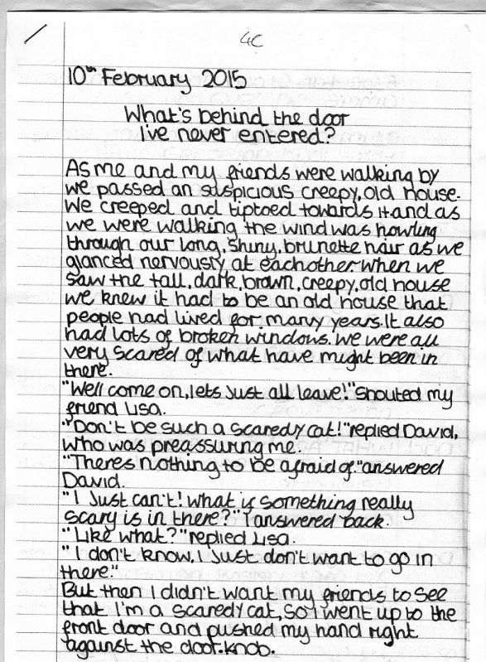 |  | Transcription:  - Accurate spelling of common words and taught words  - Distinguishes and correctly spells homophones  - Handwriting is consistent, fluent and legible
Composition:
- Able to identify audience and general purpose of writing
- Use suitable writing model to support their writing
- Use key features of taught genres
- Uses conjunctions to link sentences and paragraphs
- Use paragraphs to organise the content of the writing
- Writing links ideas within and across paragraphs
- Clear beginning, middle and end
- Balanced use of dialogue to develop plot
- Use detailed description to portray characters, setting and atmosphere
Vocabulary, spelling & grammar:
- Experimenting with new vocabulary, with some success
- Range of punctuation used with some accuracy
- Tenses throughout the writing are usually correct
- Generally subject-verb agreement is correct
- Adjectives are used to expand nouns
- Adverbs are used to expand verbs
- Consistent use of full stops, capital letters, brackets, exclamation marks and question marks
- Commas used in lists, to add extra information and to separate clauses
- Speech marks generally used correctly to punctuate dialogue
Context:
- Title given
- Brainstorming
- Independent writing and planning
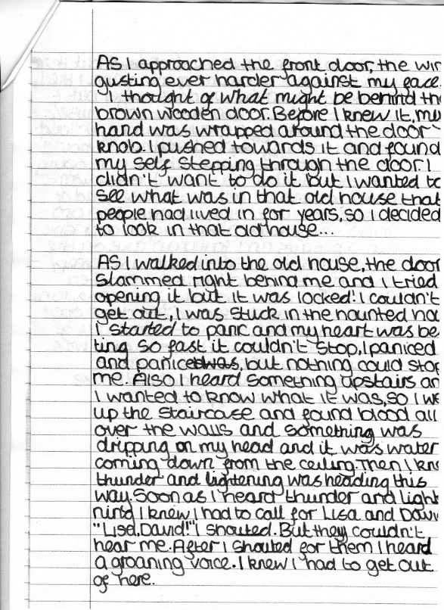 | 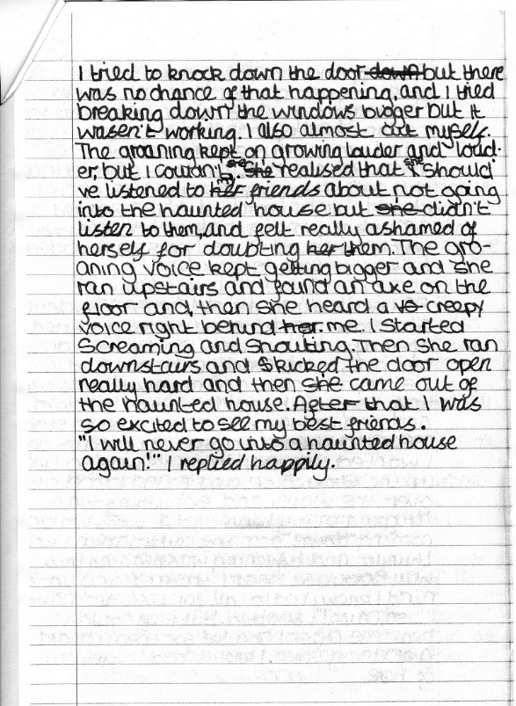

Year 5 Expected, example 2 | Exemplification
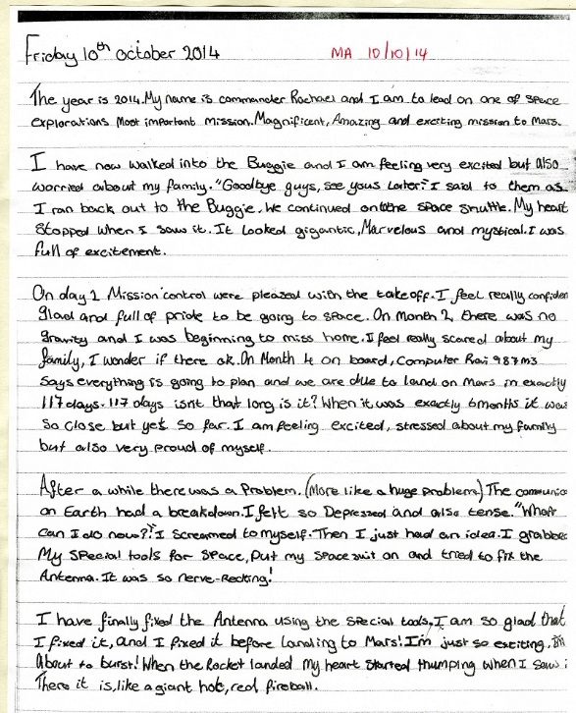 | Transcription:  - Uses knowledge of spelling patterns to spell unfamiliar words  - Reasonable attempt at unfamiliar words  - Accurate spelling of common words and taught words
Composition:
- Able to identify audience and general purpose of writing
- Use suitable writing model to support their writing
- Use key features of taught genres
- Use paragraphs to organise the content of the writing
- Clear beginning, middle and end
- Writing flows and make sense
- Writing links ideas within and across paragraphs
Vocabulary, spelling & grammar:
- Experimenting with new vocabulary, with some success
- Range of punctuation used with some accuracy
- Consistent use of full stops, capital letters, brackets, exclamation marks and question marks
- Uses prepositions
- Speech marks generally used correctly to punctuate dialogue
Context:
- Agreed planning format—modelled and scaffolded
- Independent writing
- Based on topic work

Year 5 Expected, example 3 | Exemplification
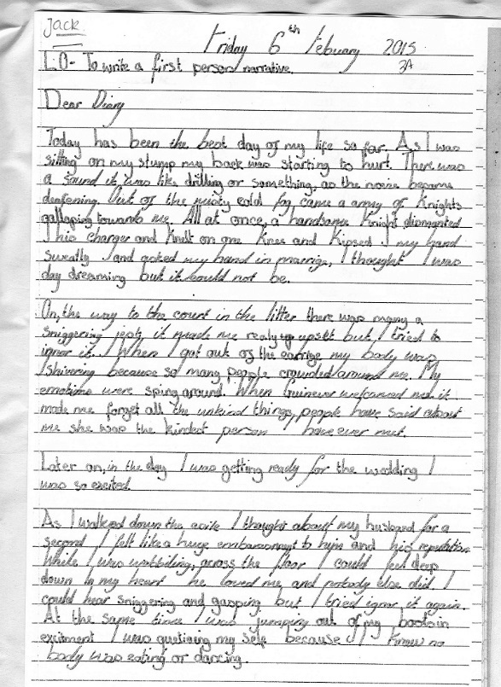 | Transcription:  - Accurate spelling of common words and taught words  - Reasonable attempt at unfamiliar words  - Handwriting is consistent, fluent and legible
Composition:
- Able to identify audience and general purpose of writing
- Emulate the style of a studied author
- Use suitable writing model to support their writing
- Use key features of taught genres
- Uses conjunctions to link sentences and paragraphs
- Use paragraphs to organise the content of the writing
- Writing links ideas within and across paragraphs
- Clear beginning, middle and end
- Use detailed description to portray characters, setting and atmosphere
Vocabulary, spelling & grammar:
- Experimenting with new vocabulary, with some success
- Range of punctuation used with some accuracy
- Tenses throughout the writing are usually correct
- Generally subject-verb agreement is correct
- Adjectives are used to expand nouns
- Consistent use of full stops, capital letters, brackets, exclamation marks and question marks
Context:
- Based on text
- Teacher modelling
- Independent planning and writing
- End of 6 week unit
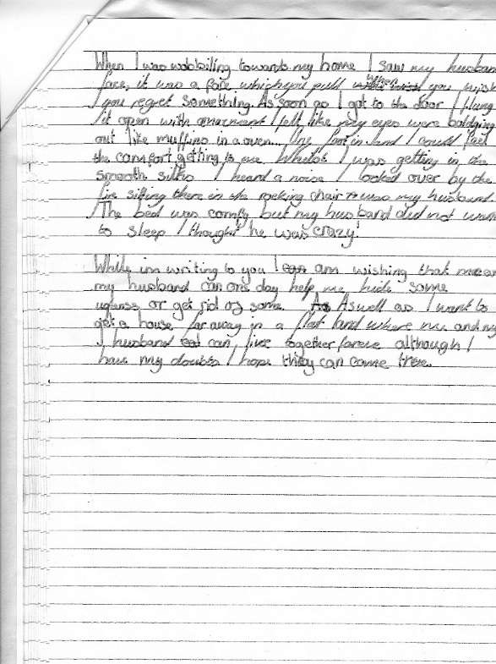

Our definition of Mastery Standard
The child would be working beyond at the expected standard level for year 5 in most areas. There is a naturalness and flow to writing which is usually rooted in a child’s experience of books and may extend beyond. The child is secure in the understanding of structures and features for narrative and non-fiction genres. Their vocabulary is exciting and often is beyond most Year 5 and fits the purpose for which they write. Sentence construction is secure and complex sentences are used with growing skill, there is an awareness of sentence length and writing is experimental and mostly successful. Stamina in writing is being displayed and pieces are sustained to the end. There is an awareness of audience and there is beginning to be a sense of manipulating the audience with the careful and considered choice of vocabulary and sentence construction and length, realising that less is sometimes more and does not seek to always overcomplicate language.
Spelling of known and taught words is generally accurate, whilst unknown words are plausibly spelt, using a selection of spelling skills. Handwriting will more than likely reflect the high attainment of the child, but this is not always the case. The child would be able to edit their own work
The next stage for this child is to ensure that they even more firmly embed their skills across the curriculum or by innovating around a theme. Writing will be more sustained and pieces will increase in stamina. The child will come away from the model supported by the teacher confidently or embellish the teacher model with skill.
National Curriculum description  NAHT Key performance indicators in bold  Objectives more suitable to Year 6 in italics | Evidence of attainment | Exemplification
Writing – transcription
Spelling – Pupils should be taught to:  - use further prefixes and suffixes and understand the guidance for adding them | - Pupil can almost always spell words with prefixes and suffixes with or without associated changes in spelling. e.g. applicable, adorable, reliable, changeable, noticeable  - Pupil can convert nouns or adjectives into verbs using suffixes: e.g.-ate; -ise; -fy (hyphen into hyphenate terrible into terrify) and is able to grasp how the meaning and function changes  - Pupil can use prefixes dis-, de-, mis-, over-, re to generate new verbs: e.g. disapprove; defuse, misunderstand, overestimate, recombine.  - Spells words containing unstressed vowels, e.g. market, mountain, and words with common prefixes, e.g. disappear, uncomfortable, impossible.  - Attempts to spell an increasing range of unfamiliar polysyllabic words using knowledge of conventions, rules and increased range of strategies, e.g. hopeful, careful, shameful. | - Get children to use a wider range of graphic information to spell monosyllabic and polysyllabic words. For example, prefixes ‘tele, bi, anti’; suffixes ‘tion, ent’; building from other words with similar patterns and meanings ‘medicine/medical’; and making comparatives‘ –er, -est, -ish’.  - Get the children to consider how prefixes / suffixes can change the word class e.g. converting nouns or adjectives into verbs using suffixes [for example, –ate; –ise; –ify] and verb prefixes [for example, dis–, de–, mis–, over– and re–]  - Discuss the meaning of these words and how they are used within other lessons.  - Get children to consider how some of these words could be used in sentences in order to strengthen their own writing both in fiction or non-fiction and across the curriculum.
- spell some words with ‘silent’ letters [for example, knight, psalm, solemn] | - Spells nearly all kn, mb, stle, mn, silent b and silent n words correctly. e.g. as at left, and solemn, debt | - Get children to collect these words and investigate them to see if they can establish a rule and then find exceptions to the rule. The letter B is usually silent when used after the letter M and also before the letter T. Examples after M: Jamb, Lamb, Comb, Tomb. Examples before T: Subtle, Doubt
- continue to distinguish between homophones and other words which are often confused | - Distinguishes and correctly spells nearly all confusing pairs: e.g. guessed/guest, serial/cereal, bridal/bridle, altar/alter, desert/dessert, draft/draught, stationary/stationery, principal/principle, aisle/isle, advise/advice, practise/practice, license/licence.  - Understanding of the definition of homographs and what their meanings are. | - Get children to collect and investigate words, create posters, silly sentences and illustrations, play matching games, bingo, say the word in a sentence  - Get children to use a wider range of graphic information to spell an increasingly more difficult, a range of homophones e.g. aisle/isle, advise/advice, practise/practice, license/licence.  - A homograph is a word that shares the same written form as another word but has a different meaning; ‘ring, bat, wind’.
- use knowledge of morphology and etymology in spelling and understand that the spelling of some words needs to be learnt specifically, as listed in English Appendix 1  - use dictionaries to check the spelling and meaning of words  - use the first three or four letters of a word to check spelling, meaning or both of these in a dictionary | - Uses conventional spelling. In addition, is able to spell nearly all the words from Year 3/4 list and half of the Year 5/6 spelling list.  - Pupil is almost always able to draw on known root words to correctly spell inflected words and other words related by meaning e.g. extraordinary, ordinarily.  - Pupil has a range of successful strategies for learning and recalling spelling of anomalous words.  - Pupil can navigate a dictionary to find the initial letter of any word and use the guide words to fine tune their search to the third or fourth letter, then independently read and usually understand the definition. | - Model the use of dictionaries/thesauruses within lessons and encourage children to use these as everyday tools in the classroom in different classroom situations.  - Play skill games/ do dictionary activities.  - Get the children to make their own topic dictionaries/glossaries for the class/ table.  - The use of dictionaries is appropriate & mainly independent.  - Encourage the use of etymological dictionaries, discuss the meanings and origins of words in spelling lessons.  - Children should have an understanding of other conventions involved in spelling. For example, root words and derivations ‘inter, interject, interrupt, interfere, interval’; eponyms ‘guillotine – Joseph-Ignace Guillotin’; and word origins, such as, ‘ pyjamas [India]’, ‘kiwi [New Zealand]’, ‘spaghetti [Italy]’.  - NB Children should have an understanding of the meanings of the root words, for example, ‘inter means between’.  - In shared reading, shared writing, guided reading and guided writing ensure that meanings of words are discussed, so that children widen their vocabulary but also their knowledge of what words actually mean, (rather than just choosing the more complicated sounding word).  - This also includes allowing them to discuss the meanings of words with adults and looking in dictionaries.
Handwriting and presentation – Pupils should be taught to:  - write legibly, fluently and with increasing speed by:  - choosing which shape of a letter to use when given choices and deciding whether or not to join specific letters  - choosing the writing implement that is best suited for a task. | - Pupil can almost always make choices over letter shapes and joins to ensure fluency, legibility, good presentation and individuality.  - Pupil can nearly always select the appropriate writing instrument and justify their choice: e.g. explain why a particular pen colour and thickness was chosen for a particular poster or flyer.  - Own style of writing is evident  - Writing is consistent in size and consistent in spacing  - Writing should fit the purpose e.g. Print for posters | - Get the children to be aware of their audience in terms of their presentation e.g. when writing for a poster, print should be clear and bold, when writing for a younger audience the writing should be well spaced, when writing for an older audience the writing should be joined and legible.  - Get children to join handwriting. This should be consistent throughout their writing except where other special forms are required. For example, printing for captions, or computer generated work.  - The joined writing should enable children to transcribe at an efficient, fluent pace developing stamina.  - When creating writing that is beyond the everyday bookwork e.g. leaflets, posters. Model how you make the choices that you make. For example, “Why do I not choose yellow on a white background when creating something that needs to be seen from a distance?” Or “How do I want people to notice information on a poster e.g. by writing in a bold font that is not too cursive?”
Writing – composition
Pupils should be taught to:  - plan their writing by:  - identifying the audience for and purpose of the writing, | - Pupil can identify the intended audience and purpose for writing  - Pupil’s writing is clear in purpose and incorporates relevant content to inform/engage the reader.  - Pupil can choose a suitable writing model to support their own writing: e.g. an information leaflet for fellow pupils offering guidance and advice on a new sport.  - Pupil shows some use of stylistic features to support purpose (formal/informal vocabulary, appropriate use of similes/metaphors, word choice for effect or emphasis...). Elaboration of detail/events may be supported through vocabulary (technical, precise/vivid language) or through explanation. | - Ensure that writing is purposeful and has an audience in mind. Children need to know that their writing has a purpose and is going to be looked at. At the start of work explain to children who they are writing for, or let them choose their own audience, when appropriate.  - Get children to understand that they can write for a range of purposes. They should understand that when they write for different reasons, the writing will have different features. For example, if they are writing a letter their address would go at the top. They should be able to discuss features of their writing.  - Children should develop their ideas by including additional information with the reader in mind and by maintaining pace throughout in longer pieces of work. For example, in narrative by using dialogue to move the story forward or to give more information about the characters, or in non-narrative, by writing a thought-provoking ending to an informational text.
- selecting the appropriate form and using other similar writing as models for their own | - Pupil can recall and use of key features of taught genres.  - Pupil writing is beginning to show a secure understanding of the features of a range of text types (choice of tense, verb form, layout, formality...). Ideas may be adapted, e.g. inclusion of contextual information on a fictitious character or the use of quotes within a report.  - Pupil uses different types of sentence structures, e.g. adverbial phrases, short sentences; pronouns establishing links with previous sentences.  - Pupil can use dialogue, when appropriate, to move the story forward.  - Pupil can use reported speech to develop viewpoint  - Pupil is beginning to develop the varying pace to sustain interest, e.g. a narrative would have a balance of action and description, dialogue and characterisation etc. across the whole text.  - Pupil is becoming confident when creating paragraphs across the genre where topic sentences are developed and extended to embellish key idea of the paragraph | - With narrative they should understand that stories are structured so that there is an opening, a conflict and a resolution but the plot need not be linear. For example, there could be counter-plots, flashbacks etc. They should understand that characters [motive] and plot are interlinked and that dialogue can move the plot forward. They should understand that stories are told by a narrator usually in the third person and are written consistently in the past tense.  - Children should be able to write rhyming and non-rhyming poetry in response to a range of stimuli using a range of poetic forms. For example, haiku, free verse etc.  - In non-fiction writing, children should be able to write non-chronological reports with a general opening statement. For example, “Whales are the largest ocean-dwelling mammals.” and a more specific comparison of two aspects of that statement. For example. “Unlike the blue whale, killer whales or orca…”  - Children should be able to write simple newspaper reports that include headlines, facts, opinions, quotations, photos and captions. These reports should focus on ‘news’ relevant to the children’s experience and/or interest.  - Children should be able to write explanatory texts. For example, explanations of a science experiment which could explain a hypothesis. Children should be able to produce persuasive writing in a range of forms, including letters, which present arguments for and against a particular issue. They should understand the notion of a balanced view/argument.
- noting and developing initial ideas, drawing on reading and research where necessary | - Pupil can almost always think aloud and record their ideas, sometimes drawing on independent reading and research. e.g. use a spidergram planning model to organise and develop related ideas drawn from reading and research  - Pupil can discuss their planning and be analytical about their own work | - Ensure that children to recall the features of all text types prior to reading them, at this point it would be likely that they would have covered most of the text types. Allow children to analyse the text types; noting both organisational and language features.  - Ensure that their prior knowledge is then built upon, for example, by adding a greater deal of technical language, or generalisers or an even more formal tone, or better grasp of the audience reading the writing.  - Make sure that children can return to the plan/ writing/ final draft in order to make adjustments and add extra information and detail.  - Use shared reading and shared writing times to explore texts and their organisational and language features and what they bring to the reader, in terms of how they make us feel or inform us. Use shared writing sessions to model how these devices are used.  - Allow children to plan their work using a variety of methods, e.g. Talk for Writing; text mapping, talking the text, boxing up, story mountains, five finger plans etc. Ensure that enough time is allowed to plan, and children are helped to get to grips with the trickiest parts of the planning process, e.g. the middle sections and resolution.  - Allow children opportunities to write across the curriculum. For example writing letter of complaint or within a text (letter writing to grandma), so that the skills that they are developing are practised in other purposeful ways
- in writing narratives, considering how authors have developed characters and settings in what pupils have read, listened to or seen performed  - draft and write by:  - selecting appropriate grammar and vocabulary, understanding how such choices can change and enhance meaning | - Pupil can draw confidently and imaginatively on what they have learned about how authors develop characters and settings to help them create their own.  - Pupil understands how a narrator’s or character’s viewpoint can be established.  - Pupil can establish a viewpoint but this may not be maintained throughout the writing e.g. by a direct appeal to the reader in persuasive writing or an explicit comment on a character by a narrator or another character.  - Pupil can show a viewpoint in order to give a clue to give a clue to something that had already happened (flashback), my brother was always saying that…  - Pupil can, where relevant, present contrasting attitudes/opinions. Some use of expert comment may be used to suggest credibility (rabbits are popular pets because they can live outdoors in all weather).  - Pupil can almost always select appropriate grammar and vocabulary and is beginning to understand how such choices can change and enhance meaning. | - Allow children to plan their work using a variety of methods, e.g. Talk for Writing; text mapping, talking the text, boxing up, story mountains, five finger plans etc.  - Ensure that enough time is allowed to plan, and children are helped to get to grips with the trickiest parts of the planning process, e.g. the middle sections and resolution, or a convincing introduction in non-fiction.  - In shared writing, model how to plan being clear about the thought process that you go through when planning, drawing on any organisational features/ information from non-fiction that might need to be included or repetition/refrains/ themes in a poem or a story.  - Allow children to plan in pairs, groups, sharing their ideas and building a secure structure to write from, even if they write individually.  - In shared reading discuss with children the effect that the author has on the reader and the skills that she/he has used to do this.  - In shared writing, model how to include some of the elements that the author has used e.g. how a character enters a room, how a character reacts to a problem, how the character moves or is described.  - Get children to consider how some of these words could be used in sentences in order to strengthen their own writing. Spend time discussing the strength of the words, considering shades of meaning within a range of similar words which is more appropriate within the sentence. What are they trying to convey? For example, sad, miserable, wretched, blue. Get the children to use thesauruses to make careful word choices that are precise, rather than make ostentatious choices, that do not fit.  - Allow children to experiment and try out vocabulary within a sentence to see if the intended meaning is conveyed. For example, “Goldilocks was an aggressive child/ Goldilocks was an insolent child/ Goldilocks was a spoilt child.”  - In shared reading and writing, guided reading and writing lessons examine the different types of sentences and consider the authors intentions. Allow children to play around with sentence types and lengths.  - Get children to experiment with sentence type and length, for example ‘do more and more clauses draw meaning away from the point or can we use a simple sentence in amongst others to say more clearly what we want to say?’  - Children should understand and use figurative language, for example, simile, metaphor, personification and alliteration for effect. For example, “Like a bear with a sore head, [simile] the boy stomped out of the room.” “A blanket of snow [metaphor] covered the street.” “All she could imagine was sea, sand and sun.” [alliteration]. “At last the sun decided to come out.” [personification].  - Get children to include more information by using effective, ambitious vocabulary which enhances the meaning and/or the mood of their writing. For example, by using proper nouns such as the names of places or characters; using a range of pronouns, such as ‘their/them’, to avoid repetition; using adverbs [how], such as ‘ruthlessly’ to qualify verbs; using adverbial words and phrases, such as ‘around about midnight/where the sea meets the shore’, to qualify when or where something happened; using more powerful verb choices, such as ‘rallied/avoid’; by using connecting words and phrases to add cohesion, such as ‘although/following this/however’, and by adding more sophisticated adjectives to create atmosphere, such as ‘perilous/clueless’.  For example, “Around about midnight, the boys set off. Although they knew the terrain was ragged they were aware of its dangers. Their instincts told them to clamber down the lowest ridge in order to avoid the most perilous rocks where the shore met the sea.”  - Vocabulary choices should be consciously selected to add detail and emphasis with the purpose and audience in mind.  - Children should understand that adverbs can be moved around a sentence which can change the emphasis of what they are trying to write. For example, “In olden times people looked strangely at disabled children/people looked strangely at disabled children in olden times/people looked strangely in olden times at disabled people.”  - Children should use a wide range of connective words and phrases, including adverbial phrases to give their writing cohesion, selecting the most appropriate to the text type, for example, when writing arguments. They may use phrases such as, ‘on the one hand it is important…but in the meantime it might be possible to…’ Connectives can link two sentences together, clauses in a sentence and paragraphs.  - Children should understand that pronouns are used instead of a noun to avoid repetition. For example, “The Mary Rose was an old ship. She sailed the ocean seas.”
- in narratives, describing settings, characters and atmosphere and integrating dialogue to convey character and advance the action | - Pupil can usually describe settings, characters and atmosphere and integrate dialogue to convey character and advance the action, evoke atmosphere through detailed description, portray characters through meaningful interaction and dialogue that moves the story on: e.g. 'Watch out, you've left the door open!' 'Too late - the dog's made a bolt for it!'  - Pupil can draw on the modelled story and their own wider reading of fiction. | - In the shared reading consider how the story moves from one place/time to another. Examine how the author does this and try to emulate some of the ways of moving plot forward.  - Children should understand the notion of setting and how settings change as stories progress and can convey a sense of what is to come.  - Children should understand that stories can open differently depending on the impact the writer wants to make in the reader. For example, by using descriptions, actions or dialogue.  - Spend time looking at how a plot is moved on in different ways, for example with dialogue, “Night is coming, we must find somewhere to shelter,” or with narration, “Soon the night clouds drew a blanket over the sun and the children settled down to sleep,” or, “Around about midnight, the boys set off. Although they knew the terrain was ragged they were aware of its dangers. Their instincts told them to clamber down the lowest ridge in order to avoid the most perilous rocks where the shore met the sea.”  - They should understand that stories are told by a narrator usually in the third person and are written consistently in the past tense.  - Discuss with children the subtlety of reaction, which can still tell us about a character’s feelings in a situation. Get children to consider obvious and less obvious reactions.  - Character reactions to situations should be a little more subtle, rather than “I was terrified” we can encourage “I drew a deep breath, ready for what was about to come.”  - Get children to link their ideas relating them to each other including past, present and future.  - Children should develop their ideas and include the notion of a theme [controlling idea] as well as the plot.  - Get children to make appropriate choices between Standard English, colloquialism or dialect.  - The writing should engage and sustain the interest of the reader throughout and should include features such as, the management of surprise, inclusion of a conflict or relationship between characters and reflection on characters and their actions.
- précising longer passages | - Pupil can almost always précis longer passages: e.g. identify key points from the passage and reformulate them coherently in their own words. | - Through deep discussion at shared / guided reading time, get children to discuss the main themes and ideas conveyed in the text.  - Encourage children to summarise in 10 sentences what the chapter, story, text is about. It is possible to focus around a particular theme, character or idea.  - Get children to create a feelings map, which helps them to pick out the main elements of the story.
- using a wide range of devices to build cohesion within and across paragraphs  - using further organisational and presentational devices to structure text and to guide the reader [for example, headings, bullet points, underlining] | - Pupil can use devices to build cohesion, including adverbials of time, place and number: e.g. linking ideas within and across paragraphs using later, nearby, secondly.  - Pupil can put related events or ideas organised into paragraphs generally maintained through use of ongoing references e.g. pronouns, adverbials, connectives (Eventually we…)  - Pupil can almost always use further organisational and presentational devices to structure text and to guide the reader: e.g. pose questions as heading or sub-headings, integrate diagrams, charts or graphs, select and integrate relevant diagrams, charts or graphs, use bullet points to organise material, link closing to opening.  - Pupil can usually produce internally coherent paragraphs in a logical sequence: e.g. using topic sentences to pose rhetorical questions which are answered within the paragraph, main idea supported or elaborated by subsequent sentences. | - Ensure that time is spent in shared reading, shared / guided writing looking at the different ways an author of both fiction and nonfiction can create cohesion across paragraphs, both in terms of organisational and language features.  - Demonstrate in shared and guided writing where cohesion could be improved. For example, by explaining that they could use an adverbial phrase at the beginning of the sentence like ‘Not long after/ at the same time/meanwhile/ in another part of town.’ Or in non-fiction using ‘similarly/furthermore/another good reason/ in addition to this’  - Get children to re-read their work. They should do this after each chunk of writing especially in longer pieces and look between paragraphs to see if they flow.
- evaluate and edit by:  - assessing the effectiveness of their own and others’ writing | - Pupil can almost always work alone and with a partner to evaluate writing against agreed success criteria  - Pupil can almost always work alone and with a partner to identify strengths and areas for improvement linked to recent teaching and feeding back appropriately and confidently to the writer.  - Pupil can perform their own compositions using appropriate intonation, volume, and movement so that meaning is clear, monitoring and maintaining audience attention, speaking loudly enough to be heard. | - Get children to re-read their work. They should do this after each paragraph especially in longer pieces.  - Encourage and build the skill of partner work in order to develop evaluation skills against agreed criteria.  - Make sure that children respond to the writing in terms of how it makes them feel and what they have enjoyed reading/hearing.  - Get children to generate idea as to how their writing could be improved. For example, by making suggestions like “I think if I am writing to the mayor to complain, I need to use more formal language to get my points across.” or “I think if I want people to come to the assembly, I need to include more detail about what is actually happening.”  - Demonstrate this by using children’s writing with a specific audience and purpose in mind. For example, writing formal/informal letters.  - Discuss with the children how they might change a particular piece of writing to improve the impact it has on the reader. Explain that sometimes words and phrases can be added or deleted for greater clarity or effect.
- proposing changes to vocabulary, grammar and punctuation to enhance effects and clarify meaning  - ensuring the consistent and correct use of tense throughout a piece of writing  - ensuring correct subject and verb agreement when using singular and plural, distinguishing between the language of speech and writing and choosing the appropriate register | - Pupil can usually propose appropriate changes to vocabulary, grammar and punctuation to clarify meaning in their own and others’ writing.  - Pupil can mostly write using tense consistently and correctly throughout: e.g. use past tense in narrative, present tense in non-chronological report and identify and correct own lapses readily.  - Pupil understands that common group nouns take the singular verb form: e.g. the football team is happy to be playing against Dullford; the government has decided to change exams  - Pupil understands that common group nouns take the singular verb form and can edit own and others' work to amend this.  - Pupil can usually identify examples of informal speech patterns and structures in their own and others' writing and amend or suggest amendments to reflect standard English usage where appropriate. | - Get children to read their work through in small sections, making specific suggestions to a writing partner or incorporating such changes in their own writing, such as: “I've written: 'I took a picture of my friend, who won the 200m sprint with his grandmother.' I need to put a second comma in there after 'sprint' to help the reader make sense of what I wrote. It makes the reader think the grandmother sprinted too if I leave it without a comma.”  - Through shared reading and shared writing and grammar lessons, encourage the children to consider the meaning conveyed when commas are in the wrong place. Do they think that the meaning is clear enough?  - Discuss with the children the need to ensure that our writing agrees in all places. For example:  - the consistent use of tense, such as past tense for narrative/present tense for instructions,  - noun/verb agreements, such as ‘I am/they are’,  - verb/tense agreements such as ‘they were dancing/we will dance/we danced’  - and irregular verb/tense agreements such as, ‘grow/grew/grown’,’ dwelt/dwell/dwelled’.  - Allow the children to find and correct mistakes within sentences in discrete grammar exercises. Use human sentences and sentence strips to help children to understand consistent grammar.
- proof-read for spelling and punctuation errors | - Pupil can usually spot most of their own and others’ spelling and punctuation errors quickly and knows how to correct them, including errors in the most recently taught spelling patterns and punctuation items.  - Pupil draws on own further knowledge from personal reading to spot and correct errors in some spelling patterns and punctuation items not yet taught. | - Allow children to read their own work allowed, looking for own errors. Use of word collections, dictionaries, spelling rules, will help to strengthen spelling knowledge.  - Examine misspelt sentences in a spelling lesson; gather ideas about how the writer could help themselves to write with increasing accuracy, using a number of spelling skills e.g. syllables.  - In shared editing/grammar/guided writing sessions, read the children’s work without the correct punctuation, ask the children what meaning is conveyed. Work on adding the correct punctuation in a group. “What meaning is now conveyed? Is this clearer for the reader?”  - Work with children on ‘human sentences’ or rearranging clauses, words in a sentence, in order to strengthen understanding of sentence structure and punctuation.
Writing – vocabulary, grammar and punctuation
Pupils should be taught to:  - develop their understanding of the concepts set out in English Appendix 2 by:  - recognising vocabulary and structures that are appropriate for formal speech and writing, including subjunctive forms  - using passive verbs to affect the presentation of information in a sentence  - using the perfect form of verbs to mark relationships of time and cause | - Pupil is able to use the present perfect tense well and is beginning to experiment with using the past perfect in narrative and recount: e.g. She has gone on holiday (and is not yet back, or we would write she went on holiday); The coach has left without you (because you have just arrived late); Shackleton had begun to plan his expedition years before his departure. | - Get the children to experiment with sentences in the context of their writing. (Particularly useful when doing character descriptions, biographies)  - NB We use the present perfect to say that an action happened at an unspecified time before now. The exact time is not important. You CANNOT use the present perfect with specific time expressions such as: yesterday, one year ago, last week, when I was a child, when I lived in Japan, at that moment, that day, one day, etc.  - We CAN use the present perfect with unspecific expressions such as: ever, never, once, many times, several times, before, so far, already, yet, etc.  - Experience-You can use the present perfect to describe your experience. It is like saying, "I have the experience of..." You can also use this tense to say that you have never had a certain experience.” I have been to France. I have never been to France.” This sentence means that you have had the EXPERIENCE of being in France; maybe you have been there once, or several times.  - Change Over Time-We often use the present perfect to talk about change that has happened over a period of time. Examples: “You have grown since the last time I saw you; The government has become more interested in arts education; My English has really improved since I moved to Australia.”  - Accomplishments-We often use the present perfect to list the accomplishments of individuals and humanity. You cannot mention a specific time. “Man has walked on the Moon; Our son has learned how to read; Doctors have cured many deadly diseases.”  - An Uncompleted Action You Are Expecting -We often use the present perfect to say that an action which we expected has not happened. Using the present perfect suggests that we are still waiting for the action to happen. Examples: “James has not finished his homework yet. The rain hasn't stopped. Susan hasn't mastered Japanese, but she can communicate.”  - Multiple Actions at Different Times - We also use the present perfect to talk about several different actions which have occurred in the past at different times. Present perfect suggests the process is not complete and more actions are possible. Examples: “The army has attacked that city five times. I have had four quizzes and five tests so far this year. She has talked to several specialists about her problem, but nobody knows why she is sick.”
- using expanded noun phrases to convey complicated information concisely | - Pupil can almost always use expanded noun phrases to convey precise and detailed information concisely: e.g. …the small playground with the horizontal climbing wall…; ...the north coast beaches with the best surf…; ...a tiny kitten with its eyes still closed...  - Pupils at this stage may still overuse the amount of expanded noun phrases or demonstrate tautology e.g. the soggy wet flannel. | - They should be encouraged add detail to their writing by generating a range of sentences. For example simple, compound and complex sentences.  - Get children to generate a complex sentence with one, or two subordinate clauses. For example, “There was a large house, which when night fell, became the scariest place in the world.” Encourage them to check that each clause has a noun and a verb and that the main clause makes sense by itself.  - Recap previous grammar knowledge acquired and touch on areas of uncertainty, particularly nouns, adjectives and commas in a list.  - Explain that nouns are the subject or object of a verb. In the sentence, “The girl sat on the wall”, “sat” is the verb, “girl” is the subject and “wall” is the object. Phrases are groups of words that work together; in a phrase, there will be one word that all the other words modify. In a noun phrase, the other words will be modifying a noun. In the sentence above, “girl” is a noun; “the girl” is a simple noun phrase. This can then be expanded with an adjective: “the tall girl” is an expanded noun phrase, albeit a very straightforward one.  - Expanded noun phrases allow us to communicate precise information in a quick, concise way. The adding of adjectives before nouns is a basic skill in the building of description, and is the simplest way to expand a noun phrase, but it requires practice to do well. Redundant adjectives should be avoided: “The soggy, wet flannel”, where soggy and wet say the same thing; “The huge giant”, where the adjective is adding no value to the already descriptive noun. Adjectives should be chosen to convey precise meaning, and where they are not needed, simplicity may be best: “The big, black, powerful Rottweiler” may not tell the reader more than “The Rottweiler”; “The small, cuddly Rottweiler” conveys useful additional information.
- using modal verbs or adverbs to indicate degrees of possibility | - Pupil can almost always use modal verbs or adverbs to indicate degrees of possibility, e.g. there might be … it could be … we may be … sometimes… possibly… occasionally.  - Pupil can understand when the modal verb form might be used in both fiction and non-fiction writing. | - Get the children to examine texts where modal verbs are used. They can express meanings such as certainty, possibility, ability, or obligation. In grammar lessons and cross curricular writing, ask the children to consider outcomes, e.g. the water might travel up the stem of the flower.  - Ask the children to apply this in their writing of non fiction, e.g. “Sharks waiting in caves, waiting for prey that may eventually pass”; “Dear Mr Brown, I was hoping that we might discuss this matter on the phone.”  - NB Modal verbs are used to change the meaning of other verbs. The main modal verbs are will, would, can, could, may, might, shall, should, must and ought. A modal verb only has finite forms and has no suffixes (e.g. I sing – he sings, but not I must – he musts).
- using relative clauses beginning with who, which, where, when, whose, that or with an implied (i.e. omitted) relative pronoun | - Pupil can usually use relative clauses beginning with who, which, where, when, whose, that or with an implied (i.e. omitted) relative pronoun: e.g. The song (that) I like is being played on Radio one; The woman who moved in next door has a daughter my age; The boy whose cast you signed broke his leg playing rugby | - Allow children to build and play around with sentences, adding in relative clauses, to further explain the sentence.  - NB A relative clause is a special type of subordinate clause that modifies a noun. It often does this by using a relative pronoun such as who or that to refer back to that noun, though the relative pronoun that is often omitted. A relative clause may also be attached to a clause. In that case, the pronoun refers back to the whole clause, rather than referring back to a noun.  - Examples: “That’s the boy who lives near school.” [who refers back to boy] “The prize that I won was a book.” [that refers back to prize] “The prize I won was a book.” [the pronoun that is omitted] “Tom broke the game, which annoyed Ali. [which refers back to the whole clause]”
- learning the grammar for years 5 and 6 in English Appendix 2 | - Pupil can usually select appropriate grammar and vocabulary and is beginning to understand how such choices can change and enhance meaning: e.g. make deliberate vocabulary choices for effect, select specialist vocabulary to match the topic.
- indicate grammatical and other features by:  - using commas to clarify meaning or avoid ambiguity in writing | - Pupil is consistent in deploying commas to clarify meaning or avoid ambiguity. Is able to distinguish the difference in meaning between : e.g. Jamie Oliver likes cooking his family and his dog and Jamie Oliver likes cooking, his family and his dog.  - Pupil demonstrates this knowledge across a range of independent writing.  - Pupil can correctly demarcate sentences with full stops, capital letters and question and exclamation marks, rarely making a mistake | - Get the children to build sentences on from a main clause. For example, “The policeman, who was clearly angry, chased the robber.” Teach children that they can use an embedded clause to add information to a sentence or make it clearer.  - Explain to the children that they will need to separate a main clause by adding information with a subordinate clause, which can be moved about but it may change the meaning of the sentence. Get children to begin to use commas to demarcate subordinate clauses in complex sentences. For example, “While the great white circled its prey, the photographer readied her camera.”  - Get children to use a capital letter at the start of a sentence, when writing the names of places, people and titles, at the start of direct speech and for emphasis. For example, “Around about midnight, the boys set off. Suddenly they heard a terrible BANG. “What was THAT?” whispered Tom.” At this stage, these should be used consistently.  - Get children to use a range of punctuation accurately. For example, exclamation marks, question marks, commas, colons, brackets and apostrophes to add emphasis, meaning and clarity to their writing.  - They should understand that punctuation is an aid to the reader and needs to be consciously selected by the writer with this in mind. For example, ‘The girl’s legs were sunburnt’ tells the reader that there is only one girl. Whereas, ‘the girls’ legs were sunburnt’ tells the reader that there was more than one girl. By moving the apostrophe the meaning has changed.
- using brackets, dashes or commas to indicate parenthesis | - Pupil can identify which word, phrase or clause of a sentence they are writing or proof-reading needs parenthesis.  - Pupil can decide whether brackets, dashes or commas are the most appropriate in each case and uses all three with growing confidence  - Pupil demonstrates this knowledge across a range of independent writing.  - Pupil is consistent in deploying commas to clarify meaning or avoid ambiguity: e.g. is able to distinguish the difference in meaning between 'The children, who had been given ice cream, were happy'; and 'The children who had been given ice cream were happy'. | - Teach the children the function of the three types of parenthesis, by sorting sentences, creating a sentence and adding in extra information, creating human sentences.  - NB A parenthesis is additional information added into a sentence as an explanation or an afterthought. For example (parenthesis shaded): “John, a 7-year-old cat from Doncaster, hid in the engine area of his owner's car for a 60-mile trip to the seaside.” “Peter, I've heard it said, used to be a teacher before he took up body building.”  - When a parenthesis is completely removed, the sentence is still grammatically correct. A parenthesis can be separated from the rest of the sentence by commas, dashes, or brackets (all called parentheses).
- use a thesaurus | - Pupil can use a thesaurus to introduce varied and precise vocabulary for effect, e.g. after proof-reading own work with a partner or alone, turns spontaneously to thesaurus to address perceived need for wider and more varied vocabulary | - When writing, encourage the children to search a thesaurus for words which convey, exactly what they want to say.
- using hyphens to avoid ambiguity using semi-colons, colons or dashes to mark boundaries between independent clauses  - using a colon to introduce a list  - punctuating bullet points consistently | - Year 6 content | - Explain where colons are used to introduce a list (frequently in non fiction writing and for emphasis in fiction). The job of the colon is simple: to introduce.  1. Use a colon to introduce a list:  There are three countries in North America: Mexico, the USA and Canada.  We can see many things in the sky at night: the moon, stars, planets, comets, planes and even satellites.  2. You can use a colon to introduce a single item, especially when you want to emphasize that item:  We were all waiting for the hero of the evening: John.  There is one thing that he will not accept: stupidity.  3. Use a colon to introduce direct speech or a quotation:  He stood up and said loudly: "Ladies and Gentlemen, please be seated."  John whispered in my ear: "Have you seen Andrea?"  As Confucius once wrote: "When words lose their meaning, people lose their freedom."  4. Use a colon to introduce an explanation:  We had to cancel the party: too many people were sick.  There is no need to rush: the meeting will be starting one hour late.  5. Use a colon to introduce examples, as shown above. For example, item 1 above reads "Use a colon to introduce a list" and ends with a colon followed by two example sentences.  - Get the children to choose how they wish to punctuate their work and then allow them to stick to this, as the only rule is that formatting must be consistent.  - Get children to point out the mistakes in incorrectly bulleted work.  - NB Formatting with bullets points  When using bullets, be consistent throughout the document with the formatting (e.g. capital letters and punctuation at the start and end of each bullet). Choose whatever format you like, but be consistent throughout your document. Below are some common formats:  Capital letter and full stop Mr Mole won the following events: - *Egg-and-spoon race. - *Toss the pancake. - *Apple bobbing. This is the most common format. Lowercase letters and no end mark Mr Mole won the following events: - *egg-and-spoon race - *toss the pancake - *apple bobbing  Punctuate like a sentence Mr Mole won the following events: - *egg-and-spoon race, - *toss the pancake, and - *apple bobbing. Some people like to maintain a sentence structure. You do not have to do this with bullet points, but it's an option. Be aware that not all your bullet points will lend themselves to this structure, so it is often difficult to maintain consistency throughout a lengthy document if you choose this method. Punctuate like a sentence with semicolons Mr Mole won the following events: - *egg-and-spoon race; - *toss the pancake; and - *apple bobbing. To be grammatically pure, you should only use this formatting when your list items contain commas.  Be Consistent!  Mr Mole won the following events:  - *Egg-and-spoon race.  - *Toss the pancake.  - *apple bobbing.  Should be a capital A on "apple bobbing."
- use and understand the grammatical terminology in English Appendix 2 accurately and appropriately in discussing their writing and reading. | - Pupil shows a growing understanding of grammar terminology appropriate to age. (noun verb adjective adverb, clauses, phrases)  - Pupil knows what function the grammar has  - Pupil is beginning to make choices about the grammar they use.  - Pupil is beginning to discuss their grammatical choices in writing and discuss an author’s grammatical choices in reading | - Get the children to talk about their work using the metalanguage for their age. Encourage them to explain their choices to a friend, whilst in the marking, planning, editing process. For example, “I used that verb because I wanted to show that he was a cunning character.”

Year 5 Mastery, example 1 |  | Exemplification
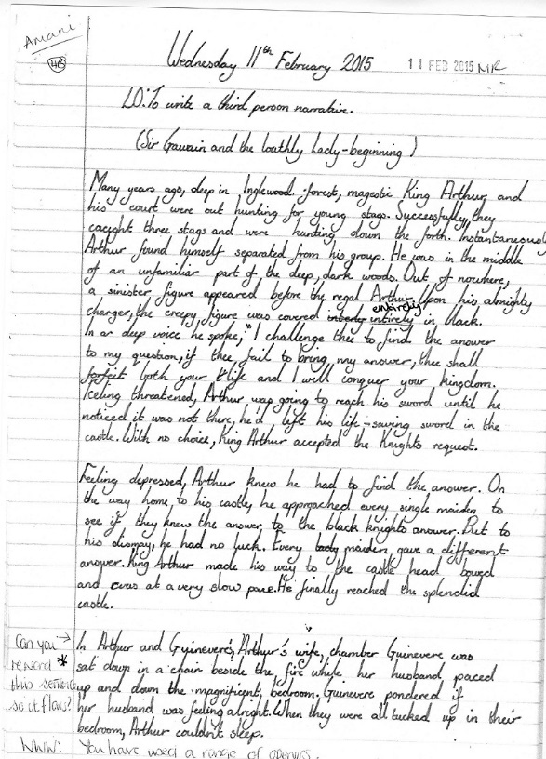 |  | Transcription:  - Almost always spell words correctly with prefixes and suffixes  - Can distinguish between homophones  - Handwriting is fluent, legible and has good presentation
Composition:
- Description of setting, character and atmosphere
- Dialogue used to convey character and advance the action
- Use of a wide range of devices to build cohesion within and across paragraphs
- Proof reading and editing to enhance their writing
- Able to identify audience and purpose of the writing
- Range of sentence types and lengths used for effect
- Balanced dialogue
- Appropriate tone
Vocabulary, spelling & grammar:
- Using relative clauses beginning with who, which, where, when, whose, that or with
- Experimenting with new vocabulary with success
- Range of punctuation
- Similes used
- Speech marks are used correctly to punctuate dialogue
Context:
- Based on text
- Scaffolded and first paragraph modelled
- Independent writing
- End of 6 week unit
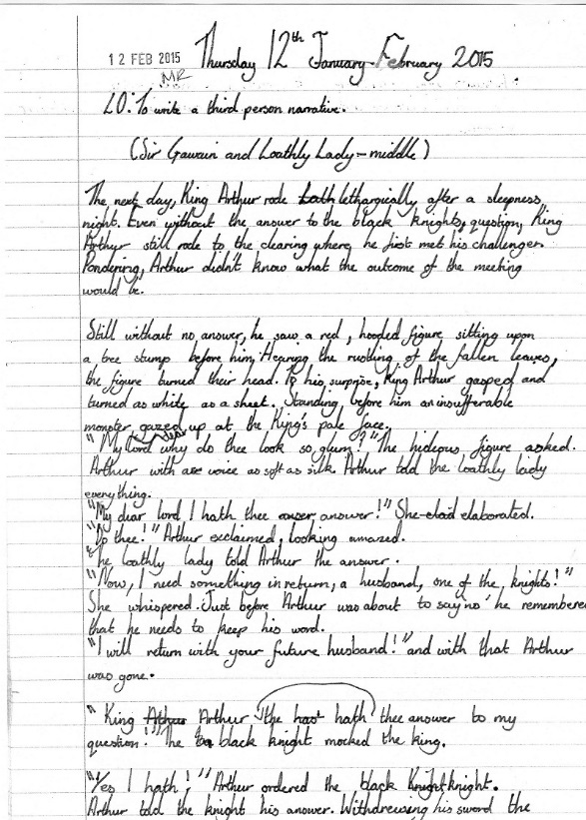 | 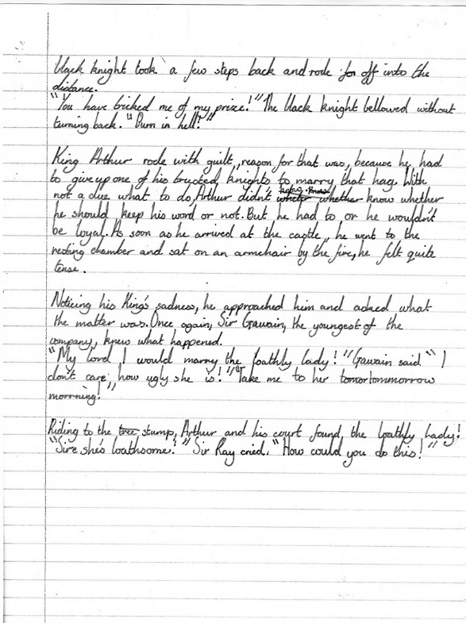

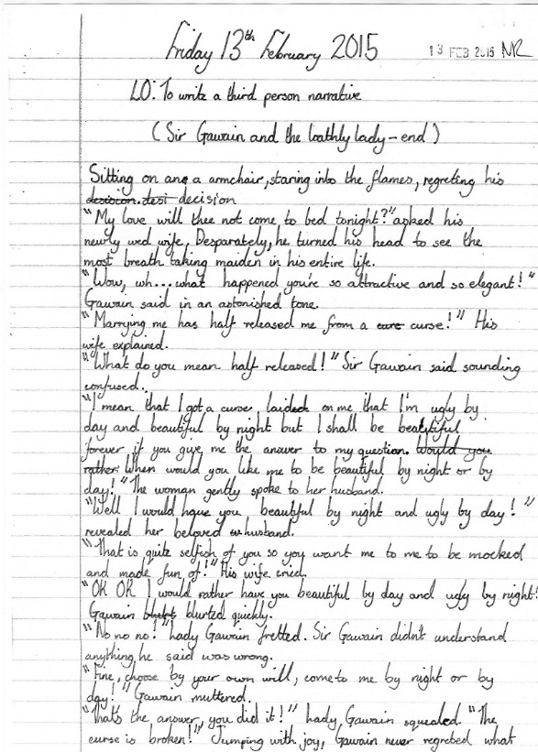 | 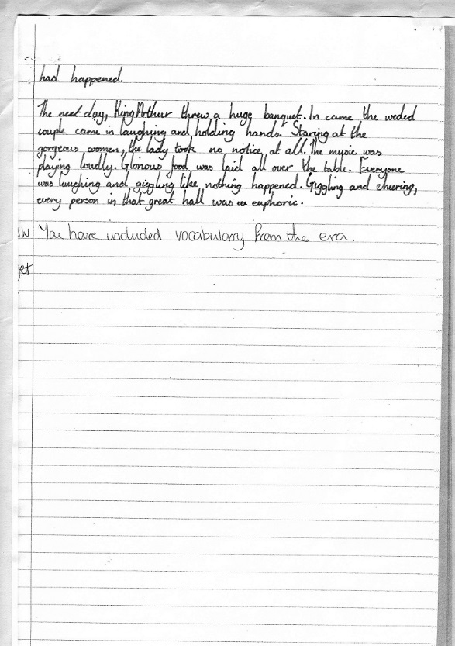
Year 5 Mastery, example 2 |  | Exemplification
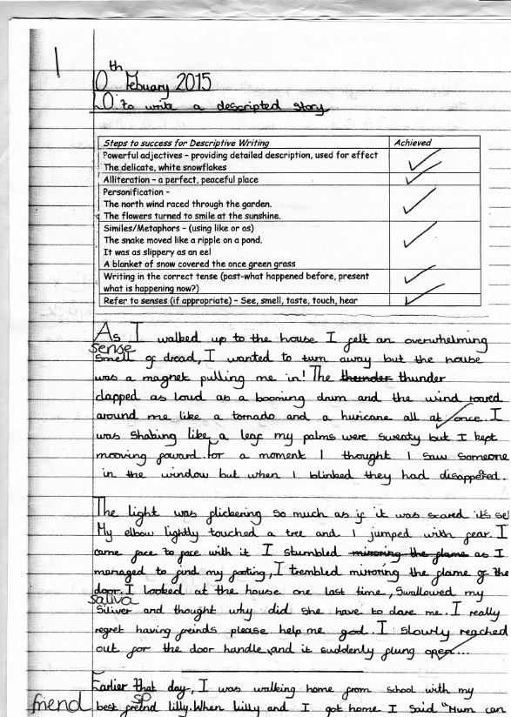 |  | Transcription:  - Most words spelt correctly with prefixes and suffixes  - Can distinguish between homophones  - Handwriting is fluent and legible
Composition:
- Description of setting, character and atmosphere
- Dialogue used to convey character and advance the action
- Use of a wide range of devices to build cohesion within and across paragraphs
- Able to identify audience and purpose of the writing
- Range of sentence types and lengths used for effect
- Appropriate tone
Vocabulary, spelling & grammar:
- Using relative clauses beginning with who, which, where, when, whose, that or with
- Experimenting with new vocabulary for effect
- Range of punctuation
- Similes used
- Speech marks are mostly used correctly to punctuate dialogue
Context:
- Title given
- Brainstorming
- Independent planning and writing
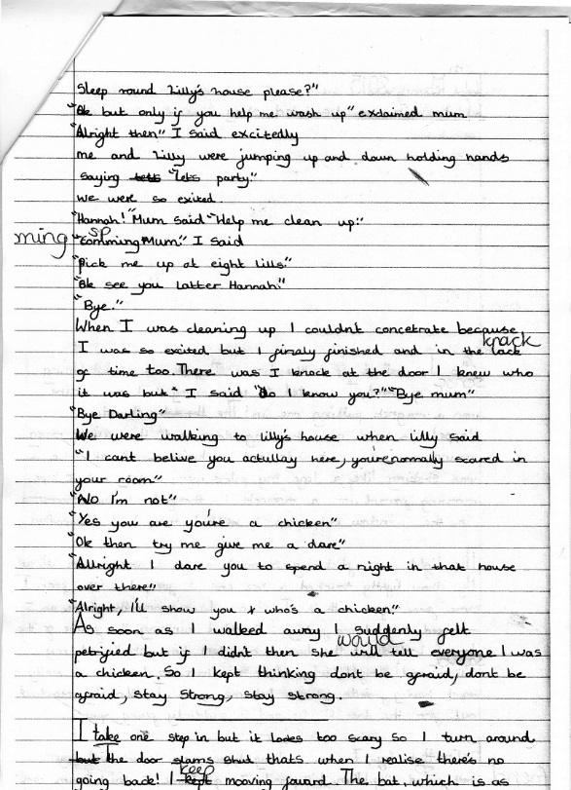 | 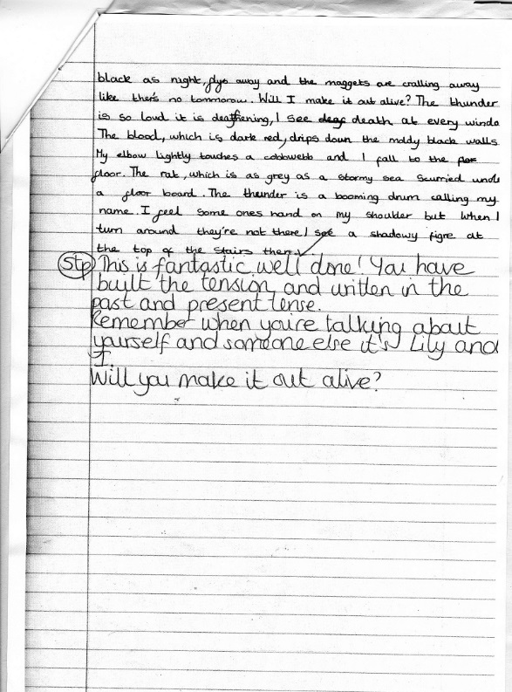

Year 5 Mastery, example 3 |  | Exemplification
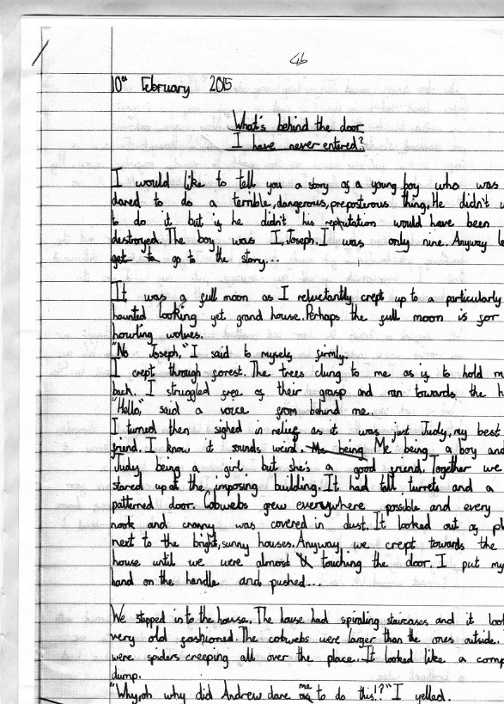 |  | Transcription:  - Almost always spell words correctly with prefixes and suffixes  - Handwriting is fluent, legible and has good presentation
Composition:
- Description of setting, character and atmosphere
- Dialogue used to convey character and advance the action
- Use of a wide range of devices to build cohesion within paragraphs
- Able to identify audience and purpose of the writing
- Range of sentence types and lengths used for effect
- Balanced dialogue
- Appropriate tone
Vocabulary, spelling & grammar:
- Experimenting with new vocabulary with success
- Wide range of punctuation
- Speech marks are used correctly to punctuate dialogue
Context:
- Title given
- Brainstorming
- Independent planning and writing
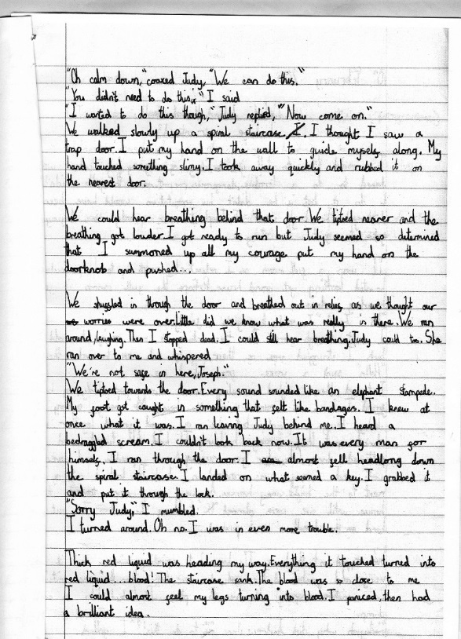 | 